Setting up R

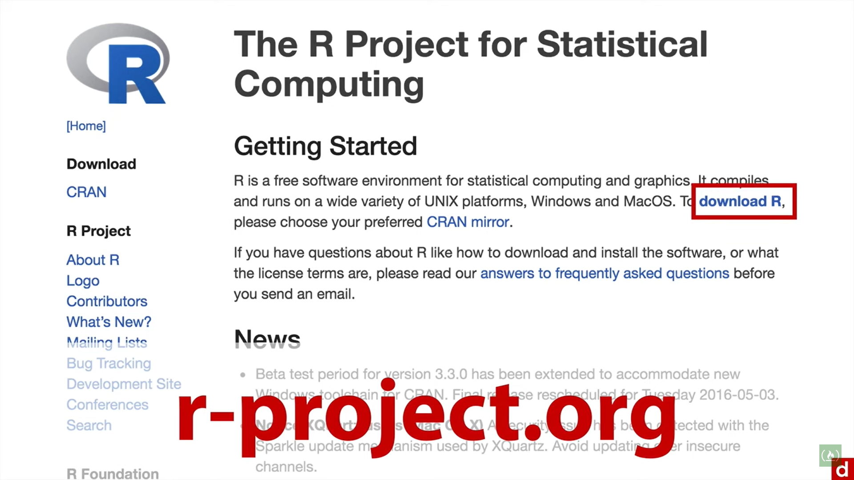

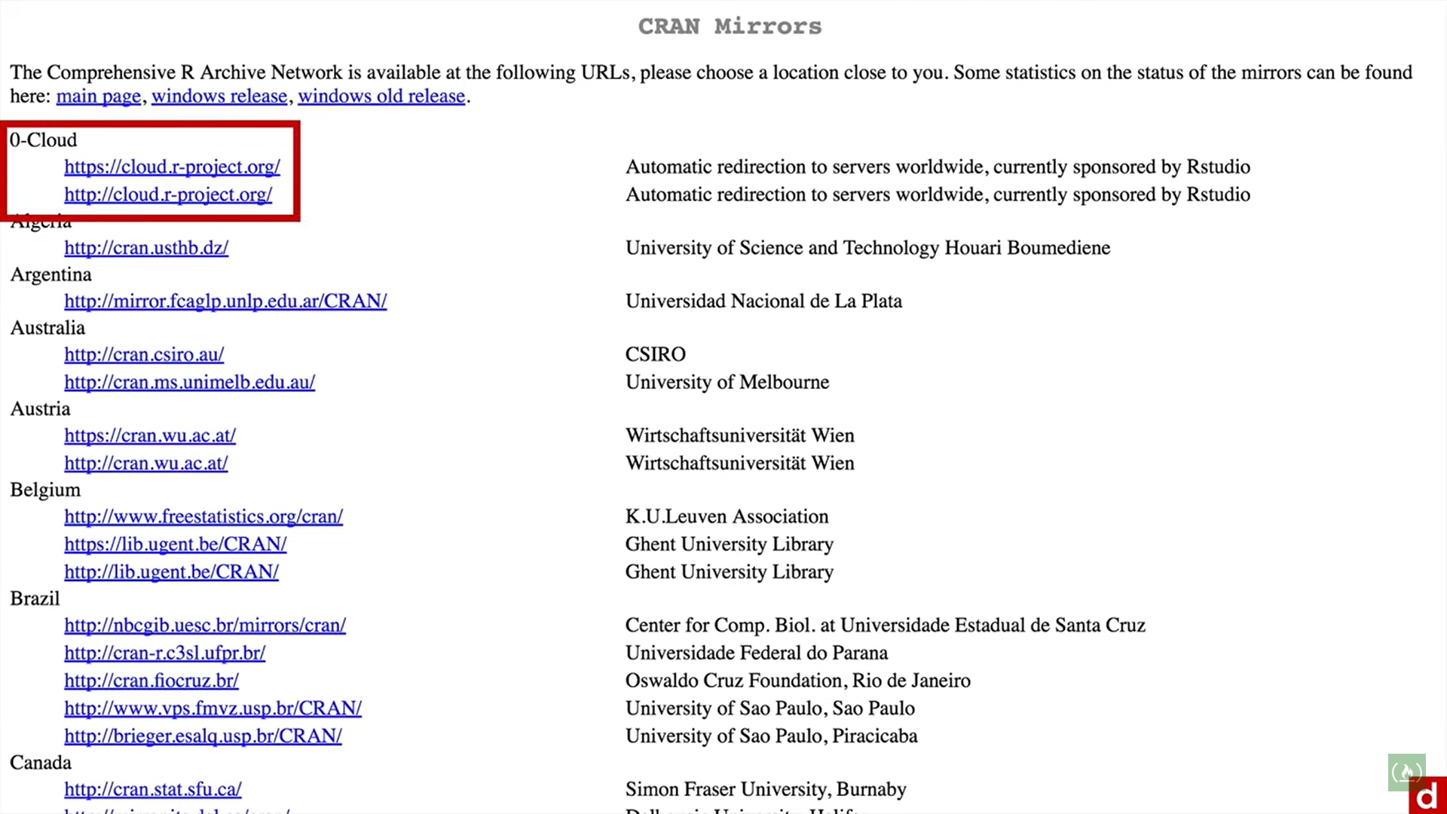

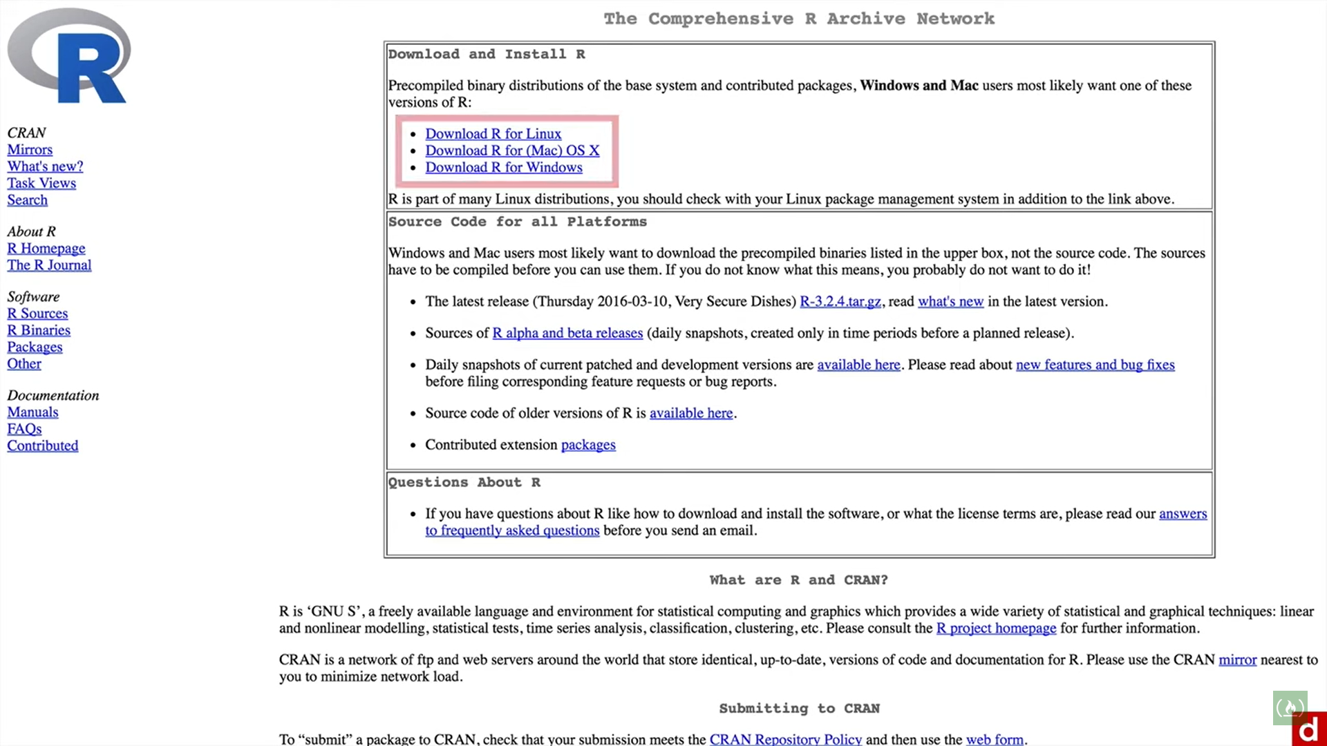

.r extension is for a r source or script file.

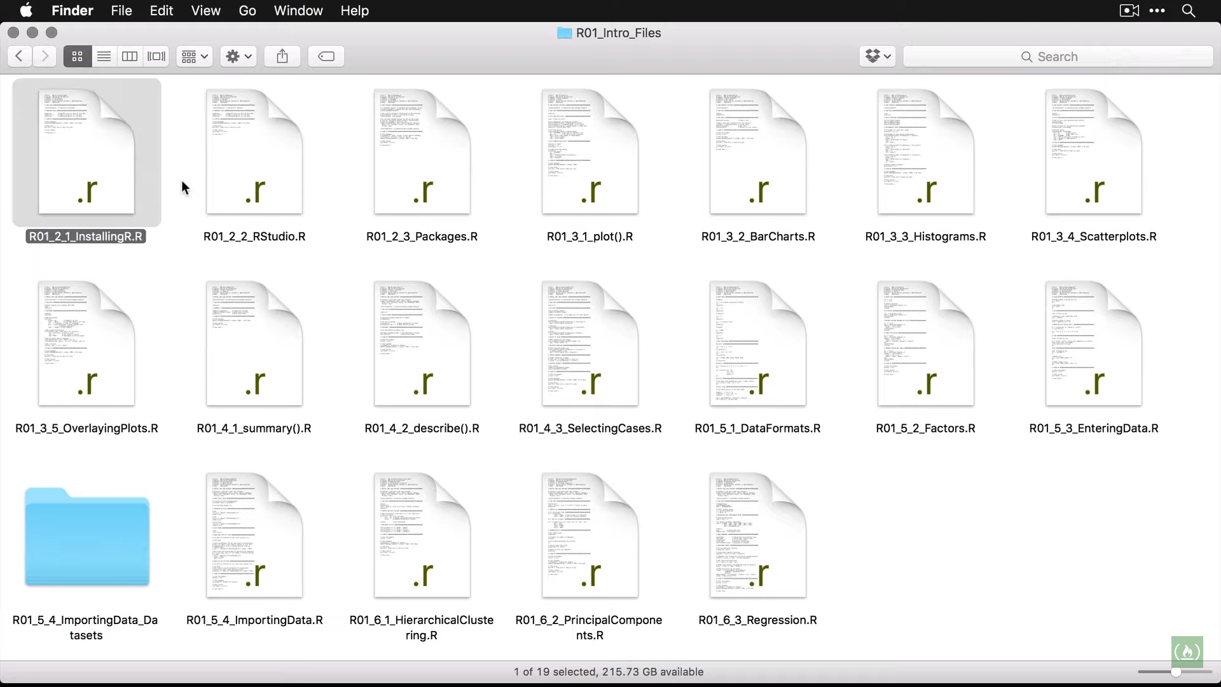

Double clicking on above file shows:

Source/Script window (left)

Console window(right)

#comments

<ctrl+enter> to execute a line on left and view result on right.

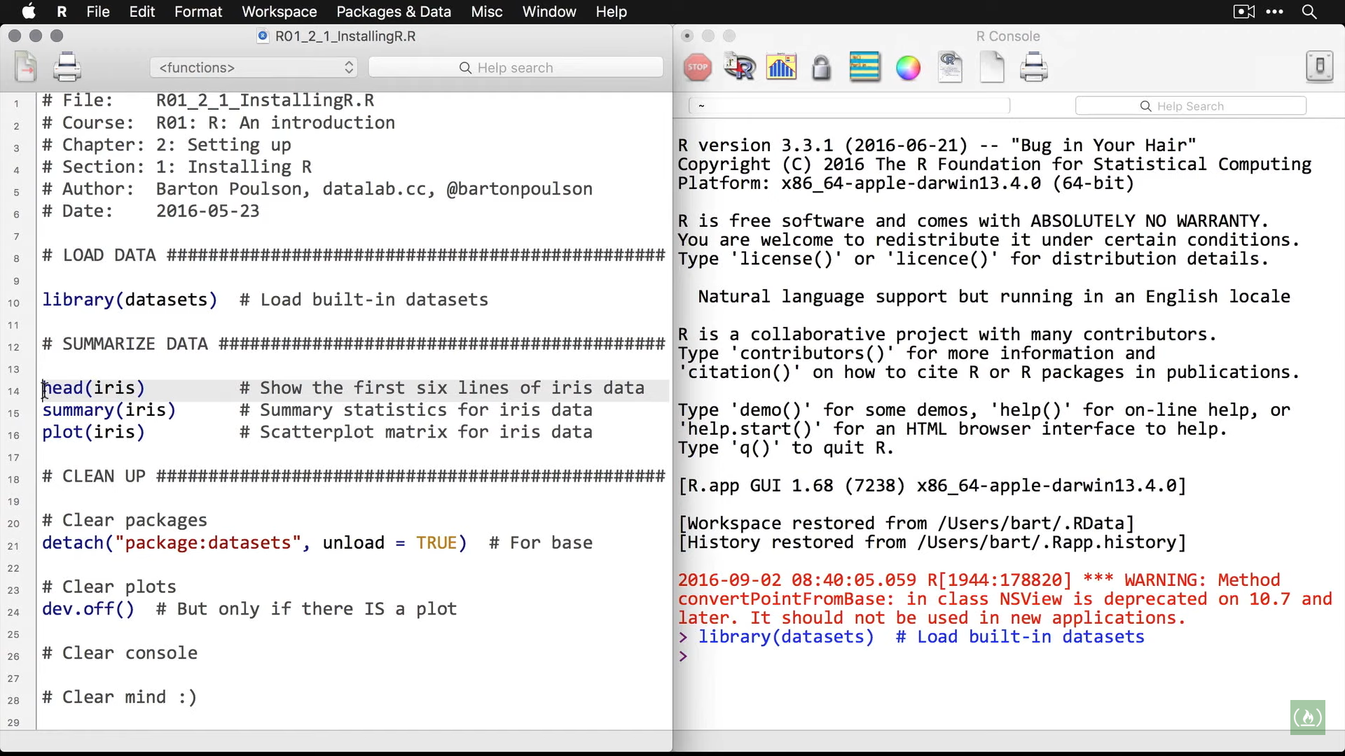

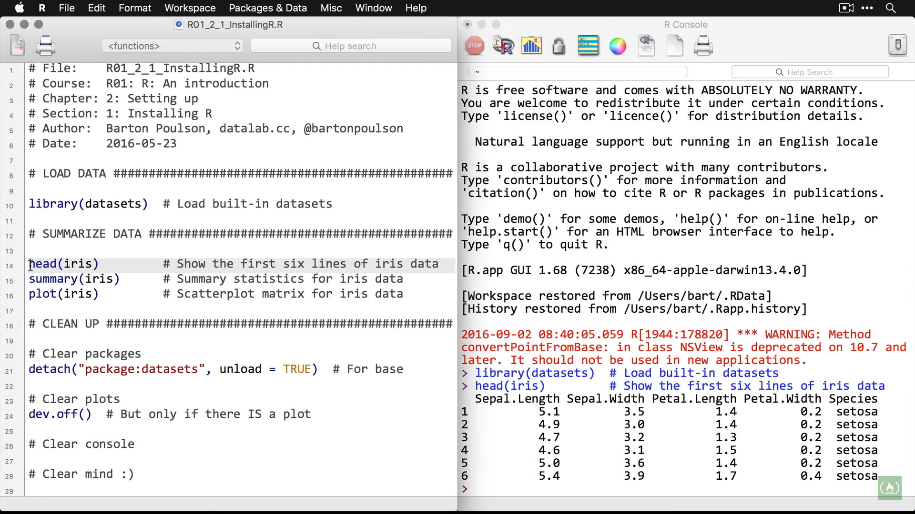

Descriptive statistics

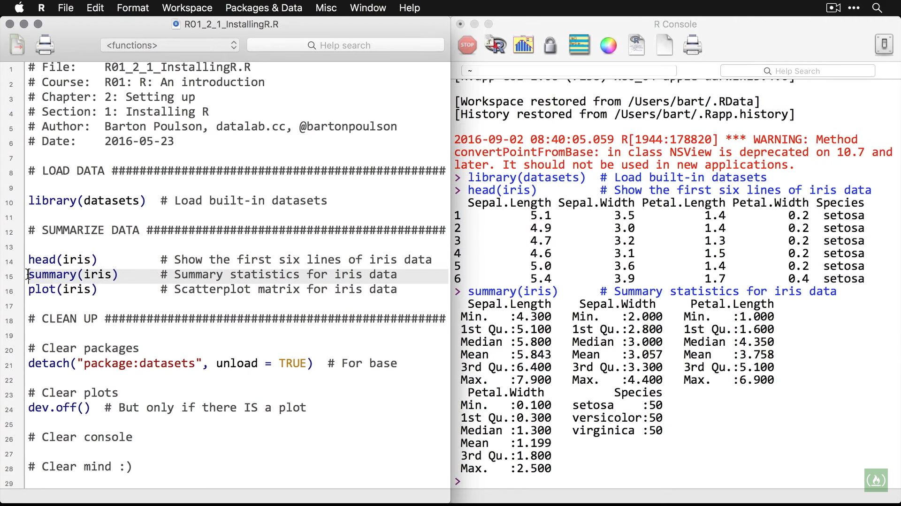

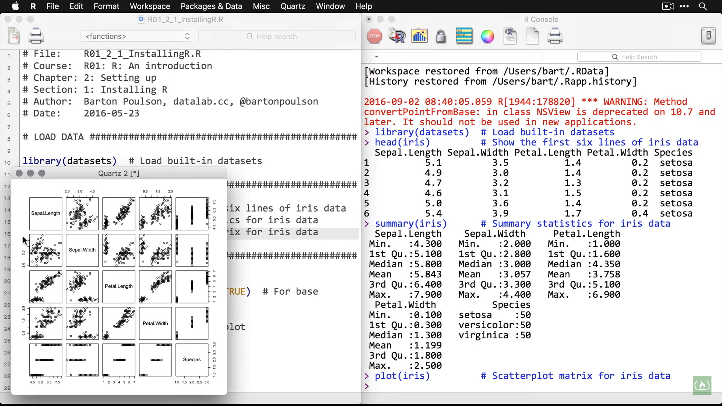



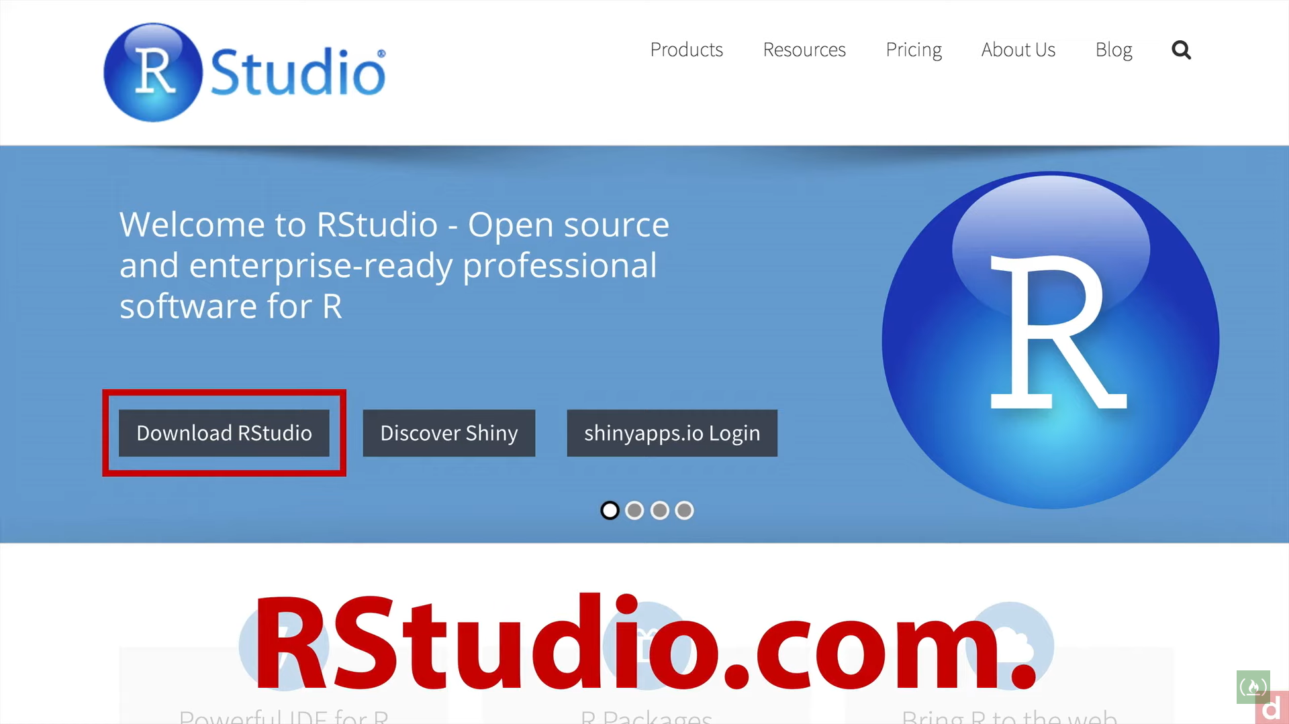

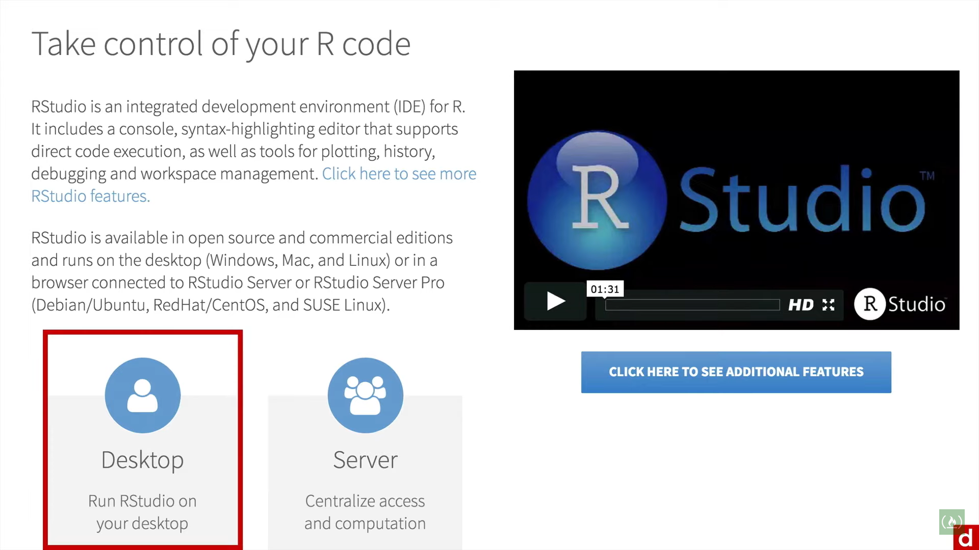

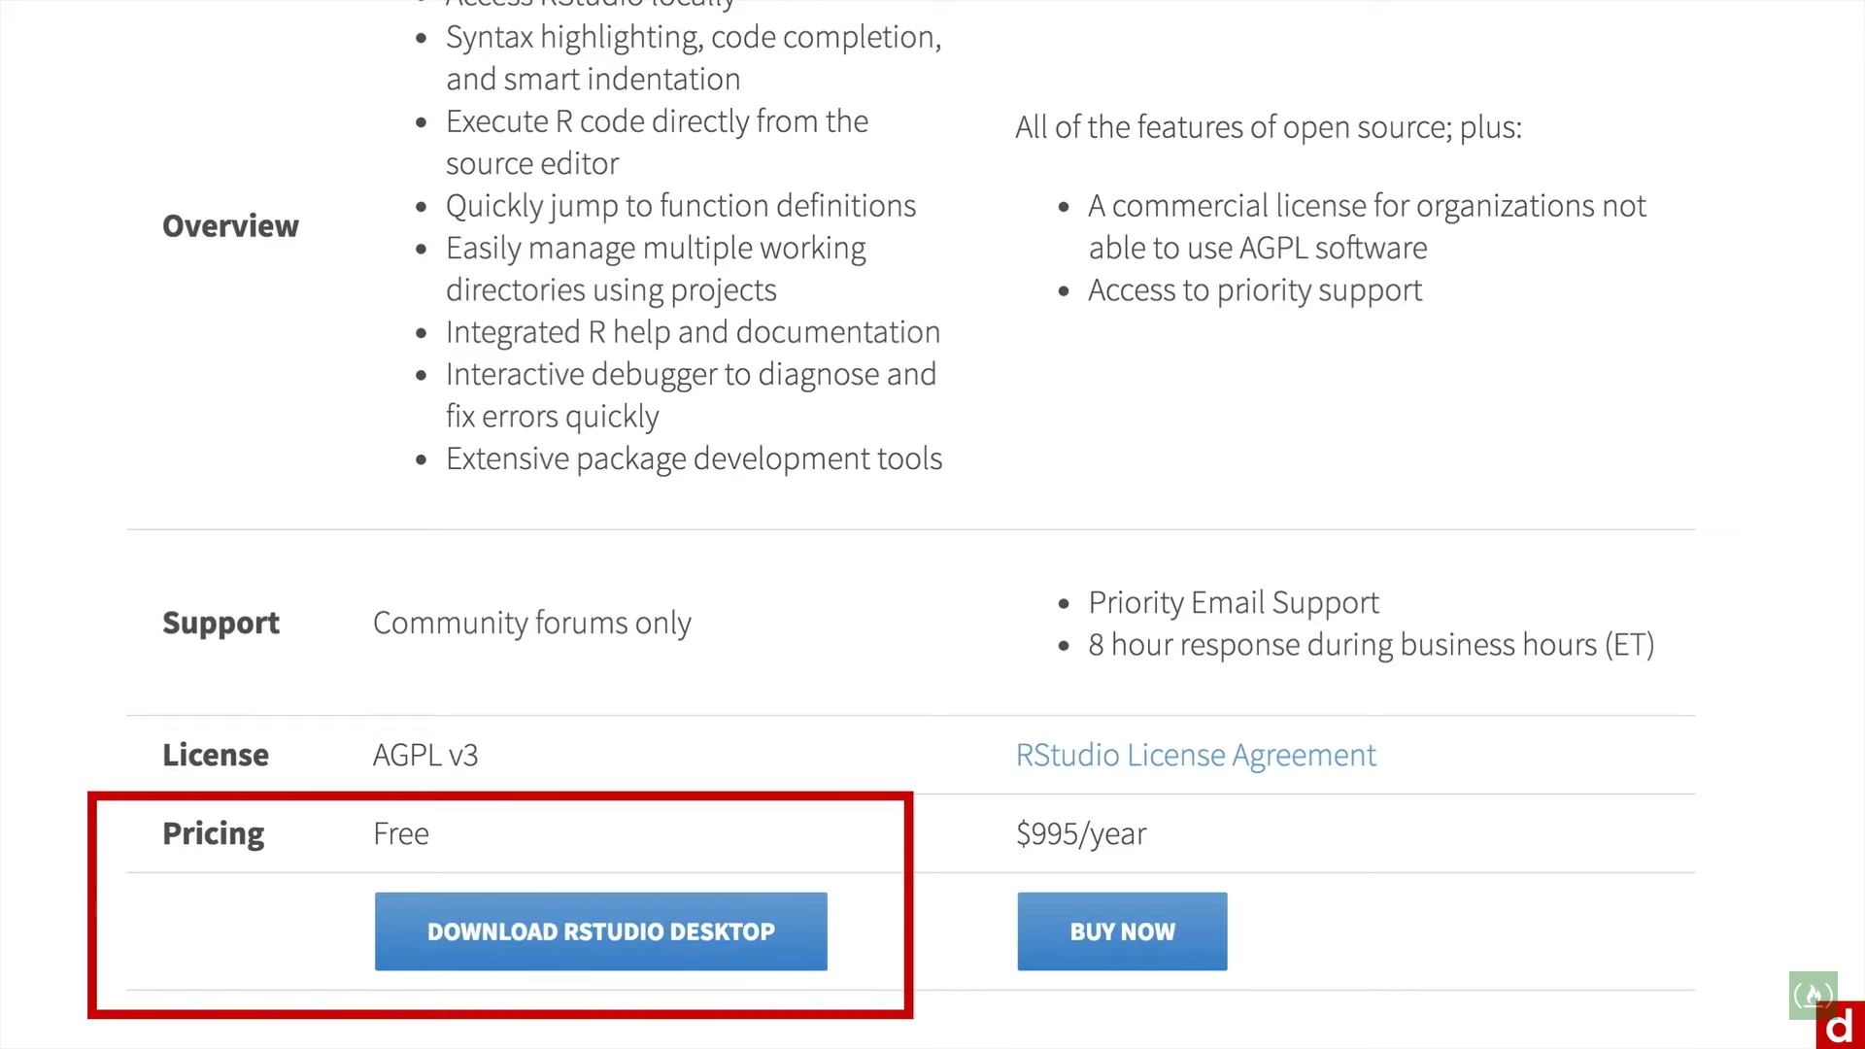

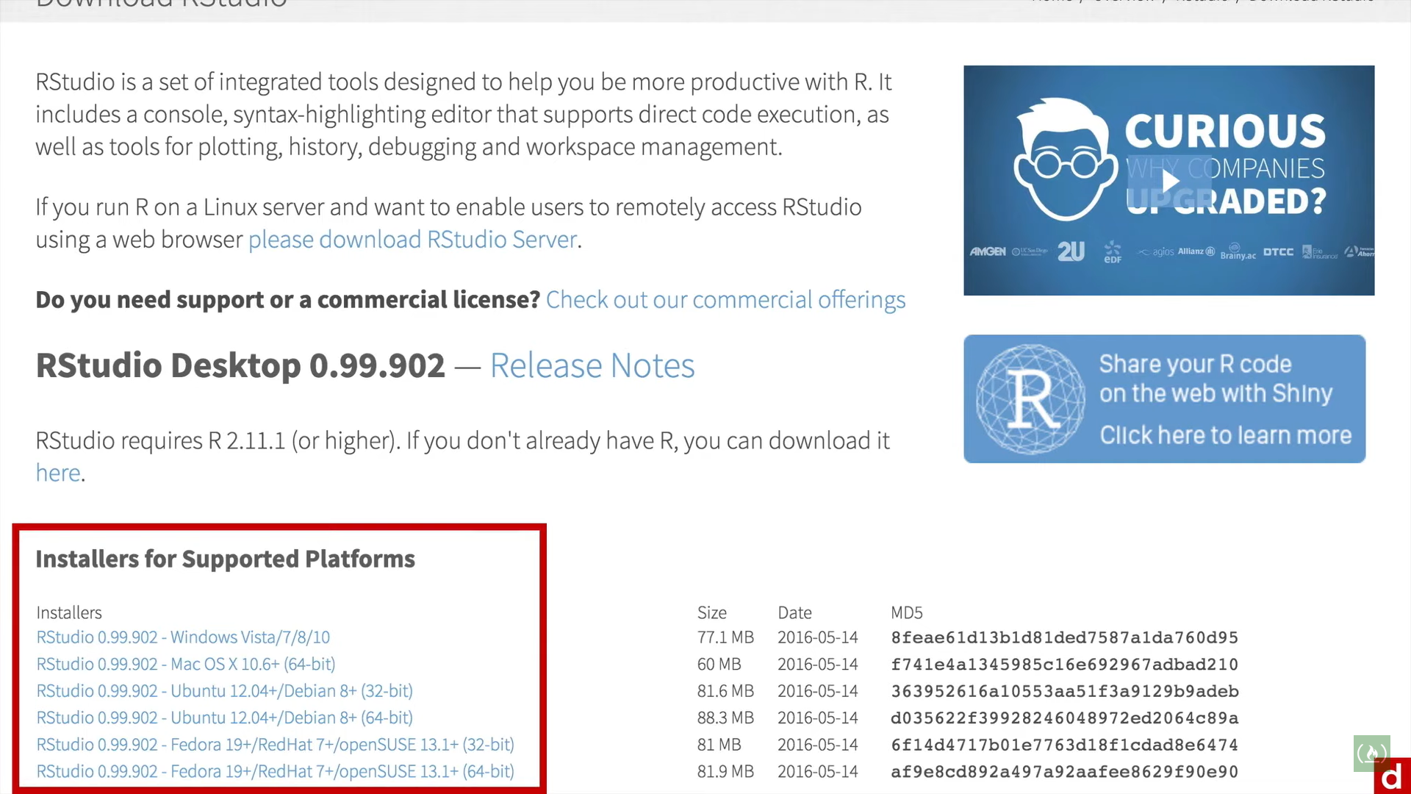

In R studio

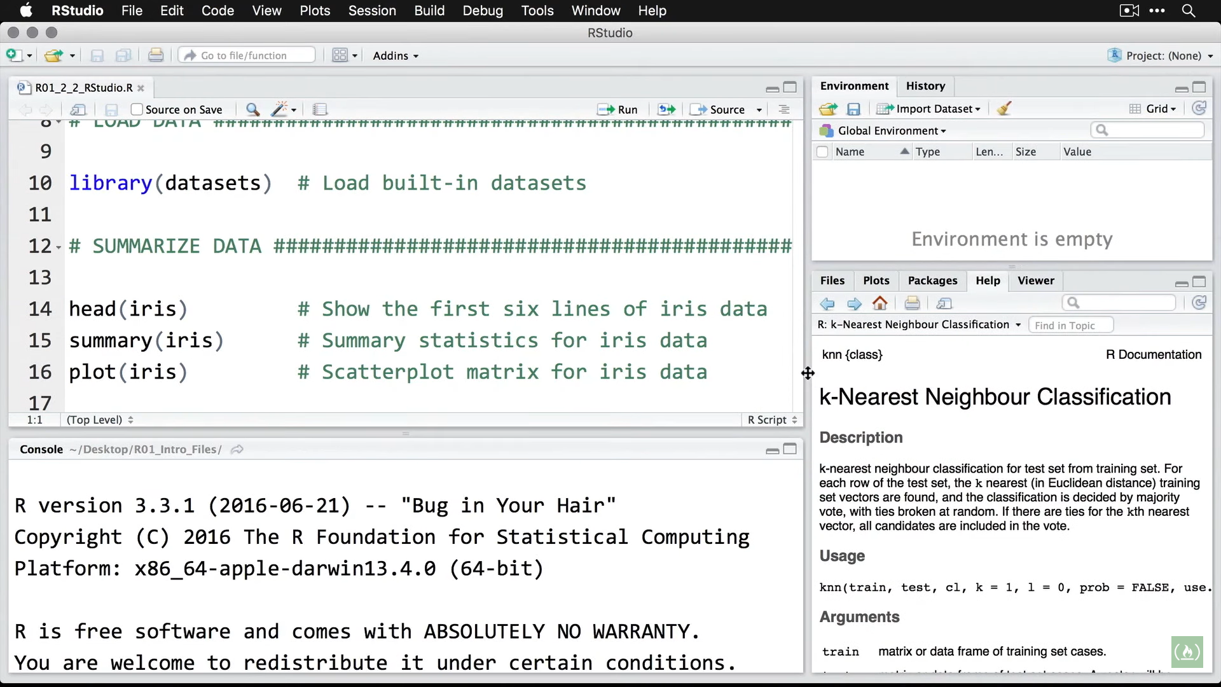

Packages are bundles of code that add new functions to R.

Base Packages: Installed with R but not loaded by default.

Contributed Packages: Need to be downloaded, installed & loaded separately.

1. CRAN (comprehensive R archive network)
2. Crantastic
3. GitHub

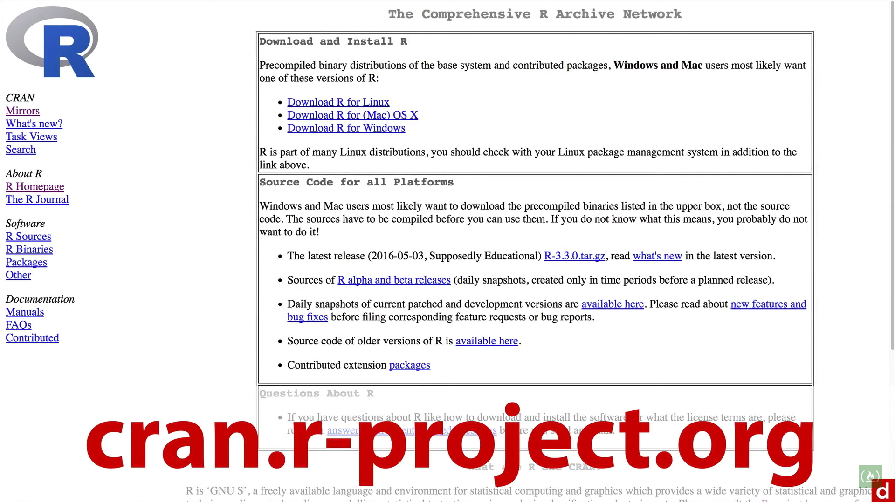

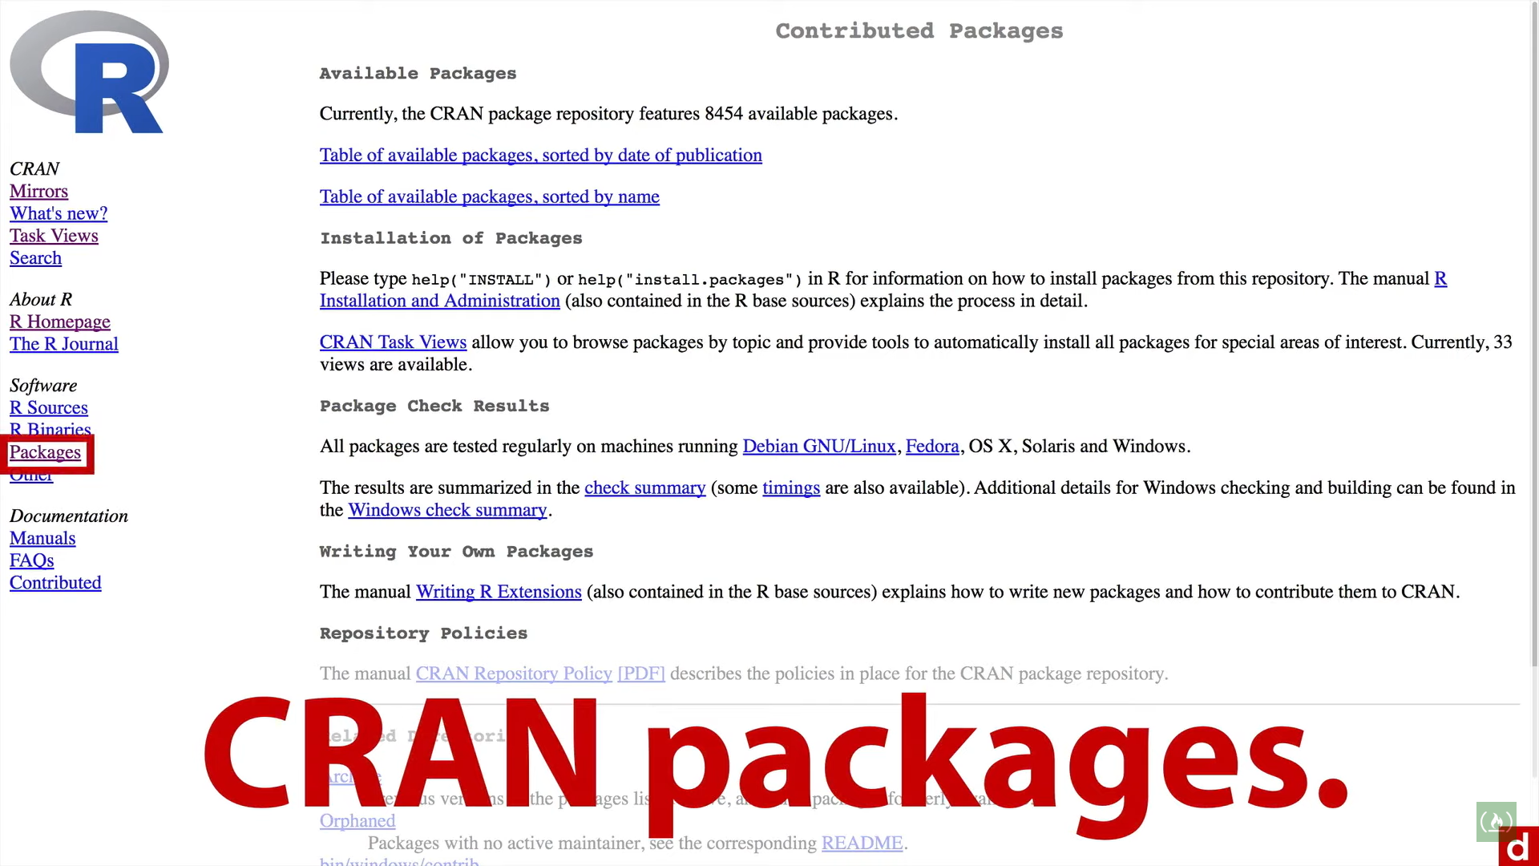

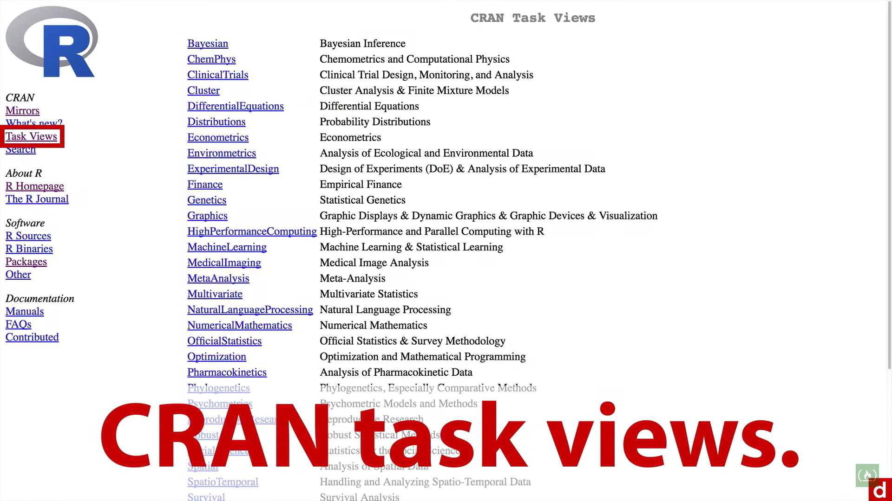

Or

Crantastic

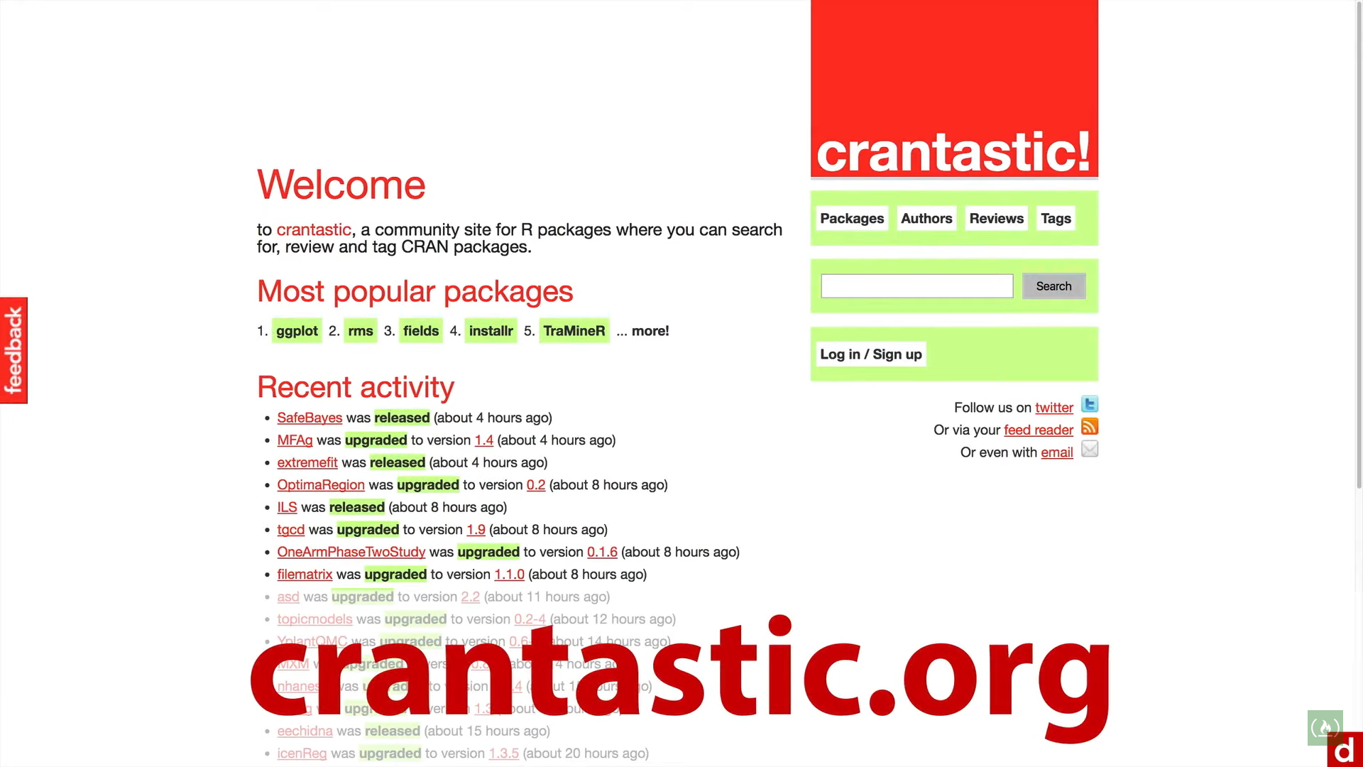

Github

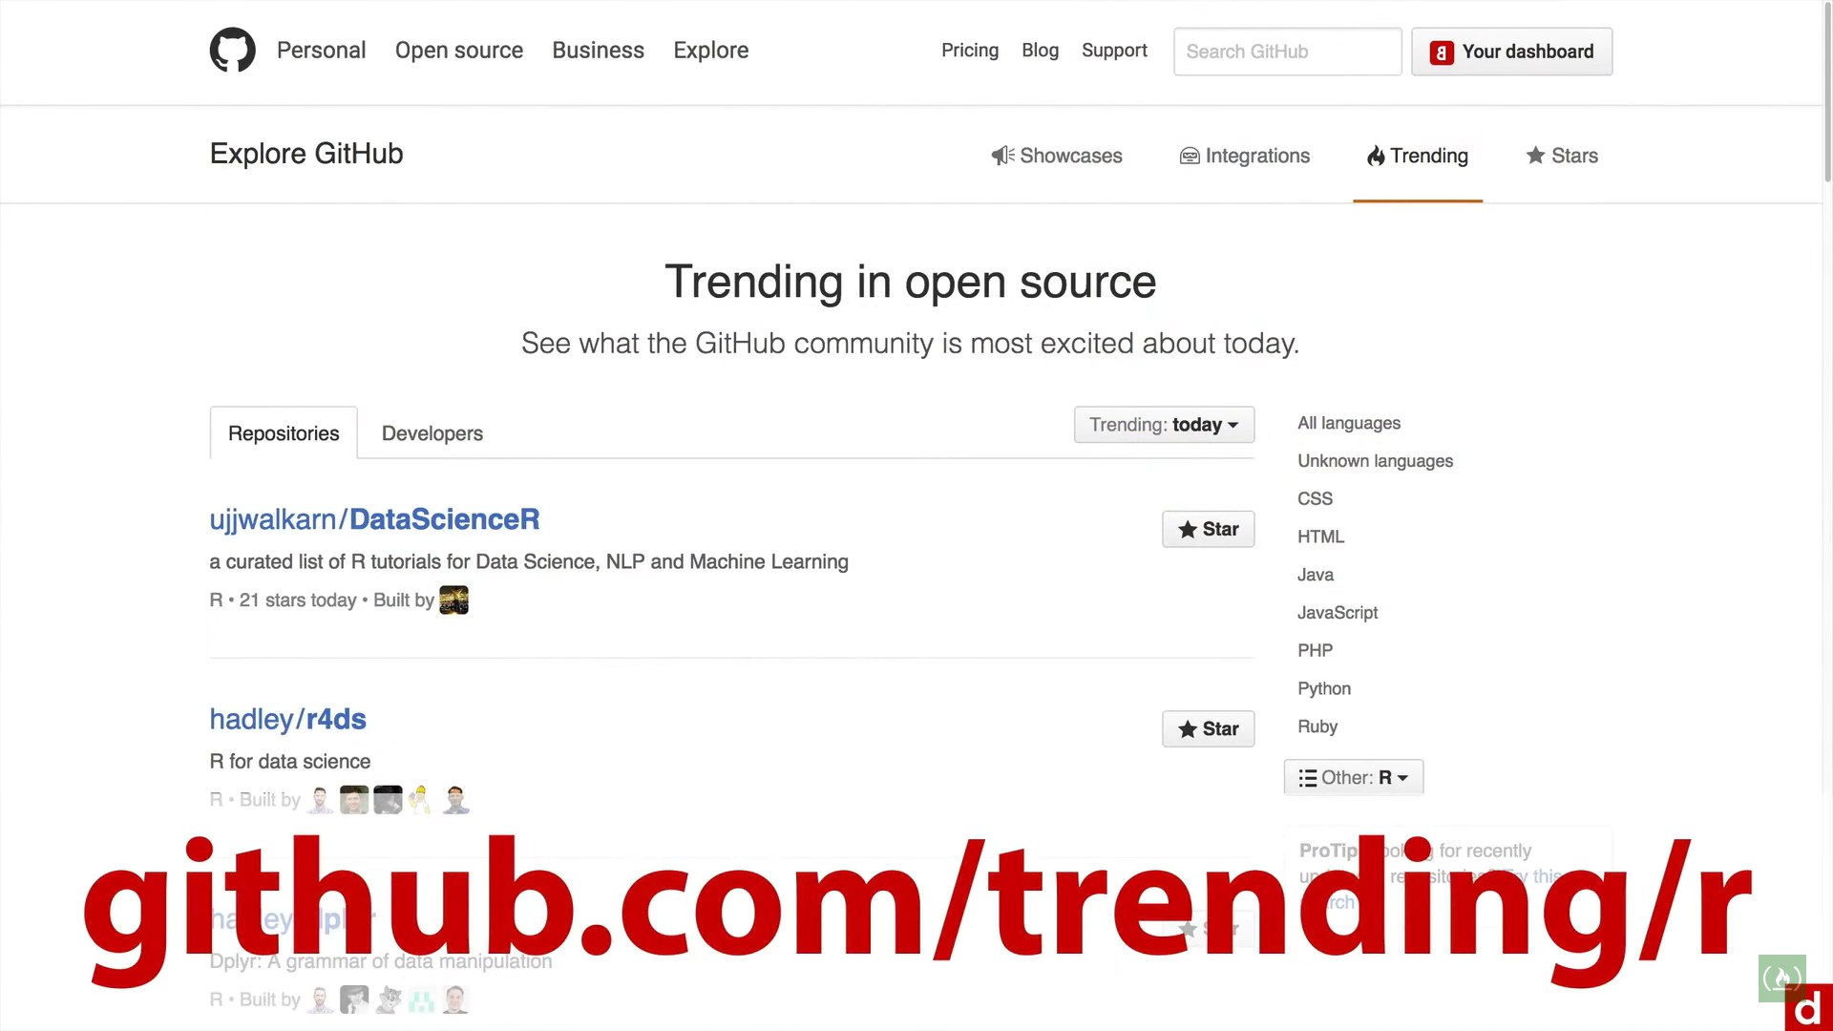

Some important ones:

dplyr: for manipulating dataframes

tidyr: for cleaning up information

stringr: for working with strings/text information.

lubridate: for manipulating data information

httr: for working with website data

ggvis: for grammer of graphics i.e. interactive visualization

ggplot2: common package for creating graphics or data visualizations

shiny: to create interactive applications to be deployed on websites

rio: for r input/output i.e. for importing & exporting data

rmarkdown: for creating interactive notebooks or rich documents.

One package to load them all: pacman

To try these packages open up

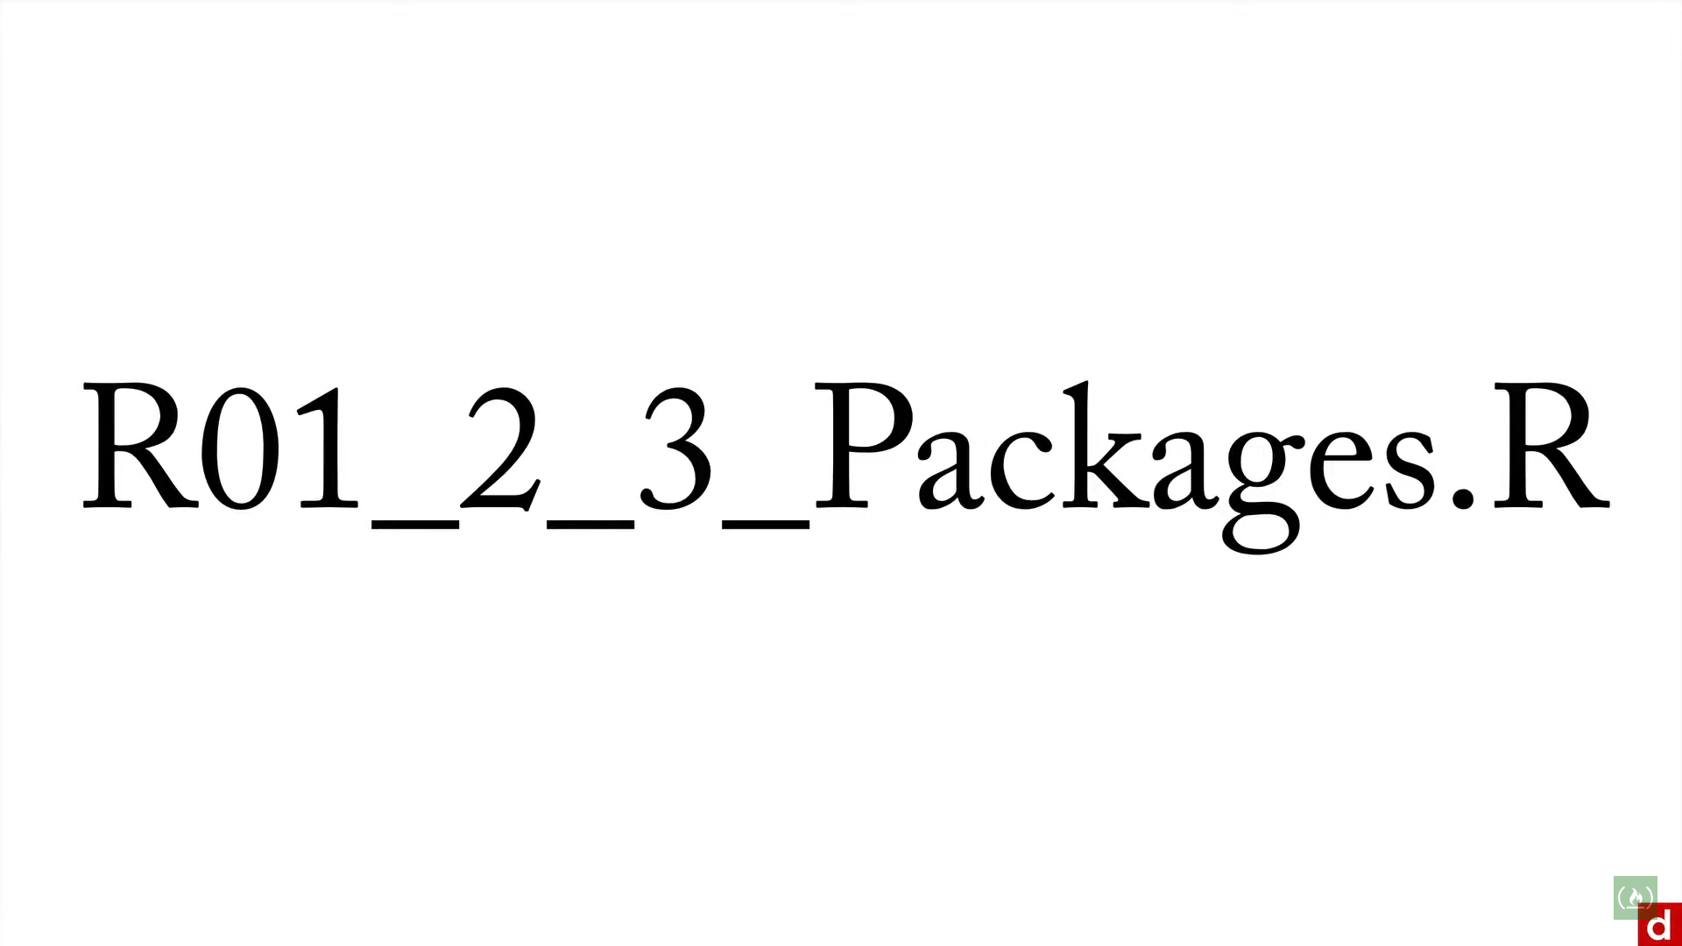

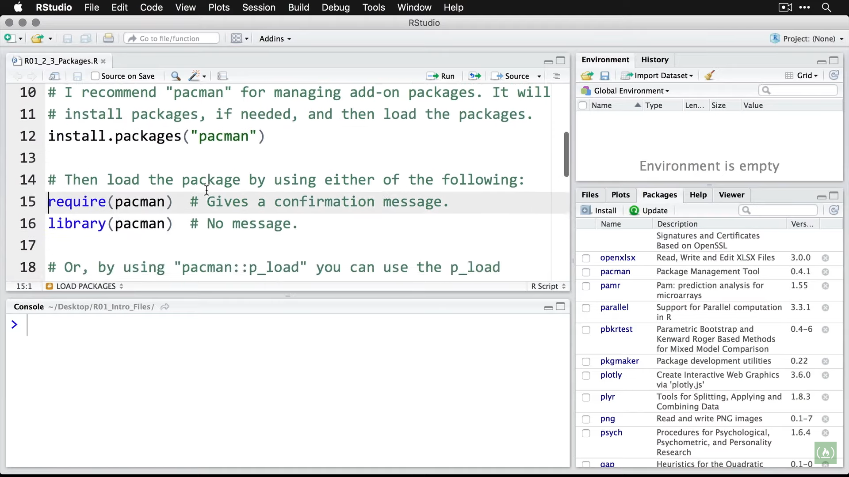

Install package and then load it using require/library option.

Then load the packages needed

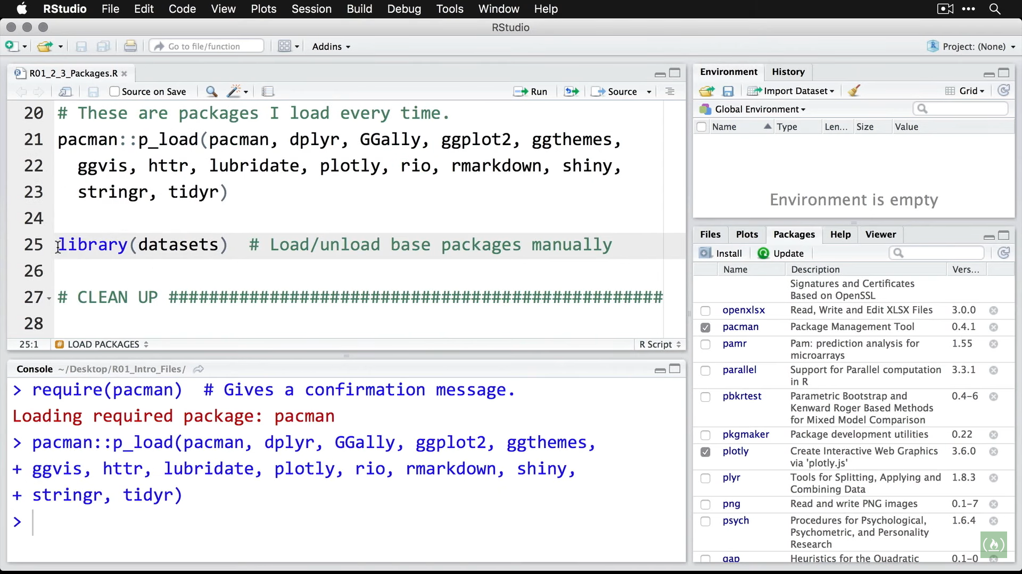

Note** If the package isn’t already installed, pacman will install it and load it.

To unload packages

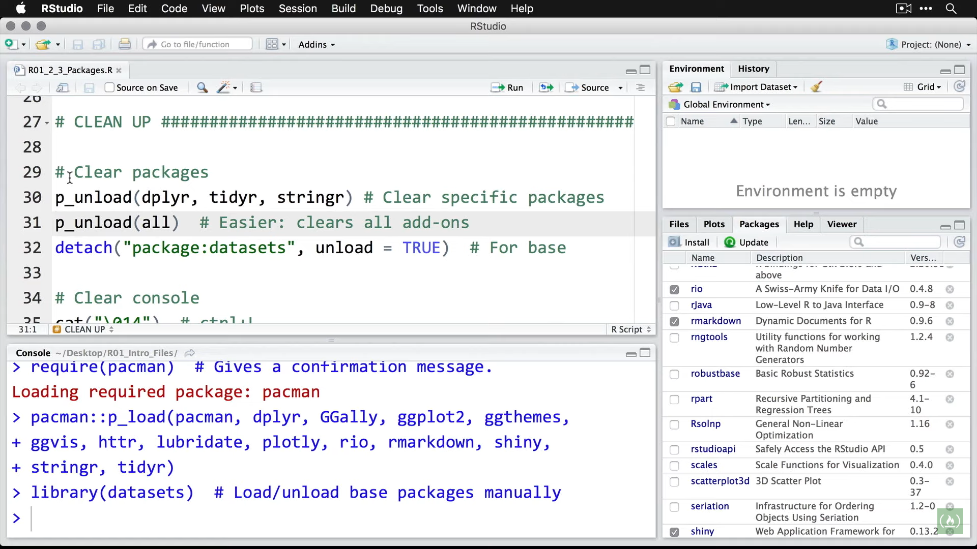

Note** detach used for mainly standard base packages of R.

**Plots**

Basic Visualization using plot()

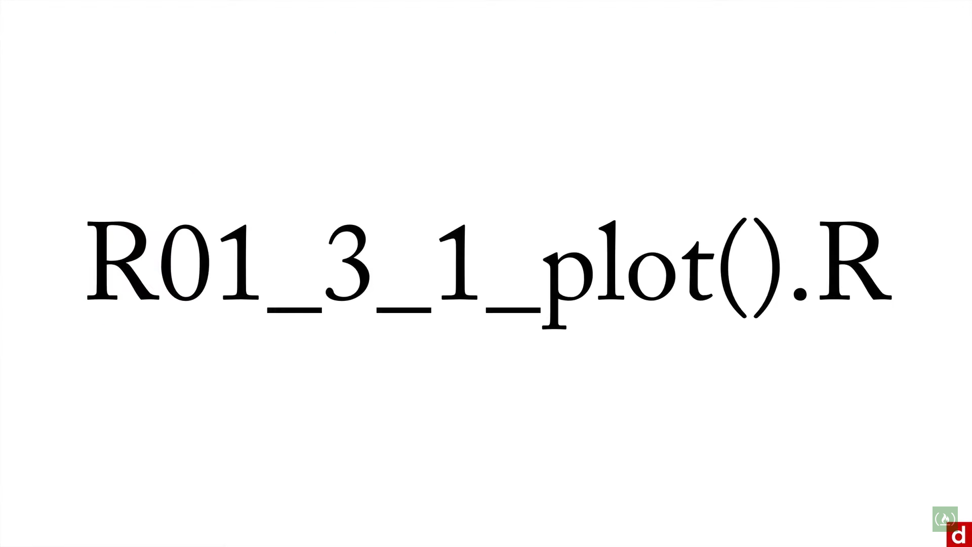

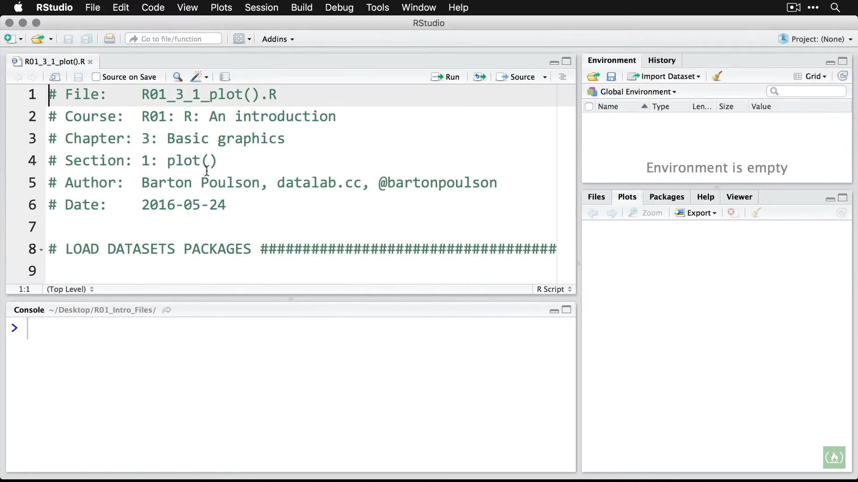

Load the datasets

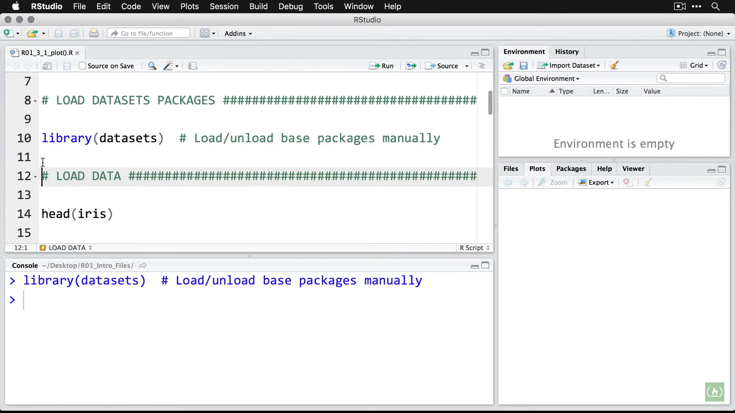

Looking at first few lines of iris dataset

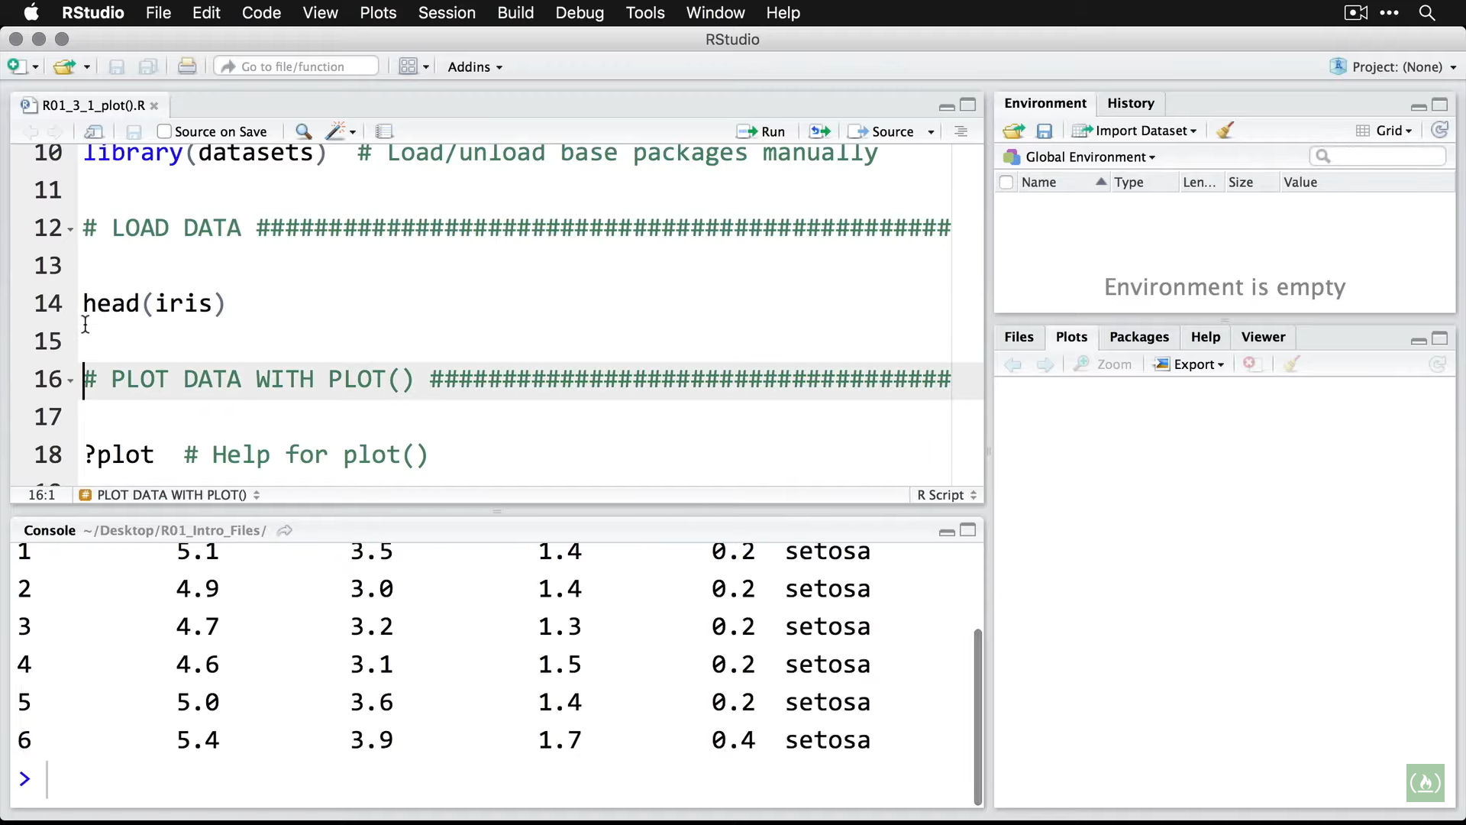

Zooming in

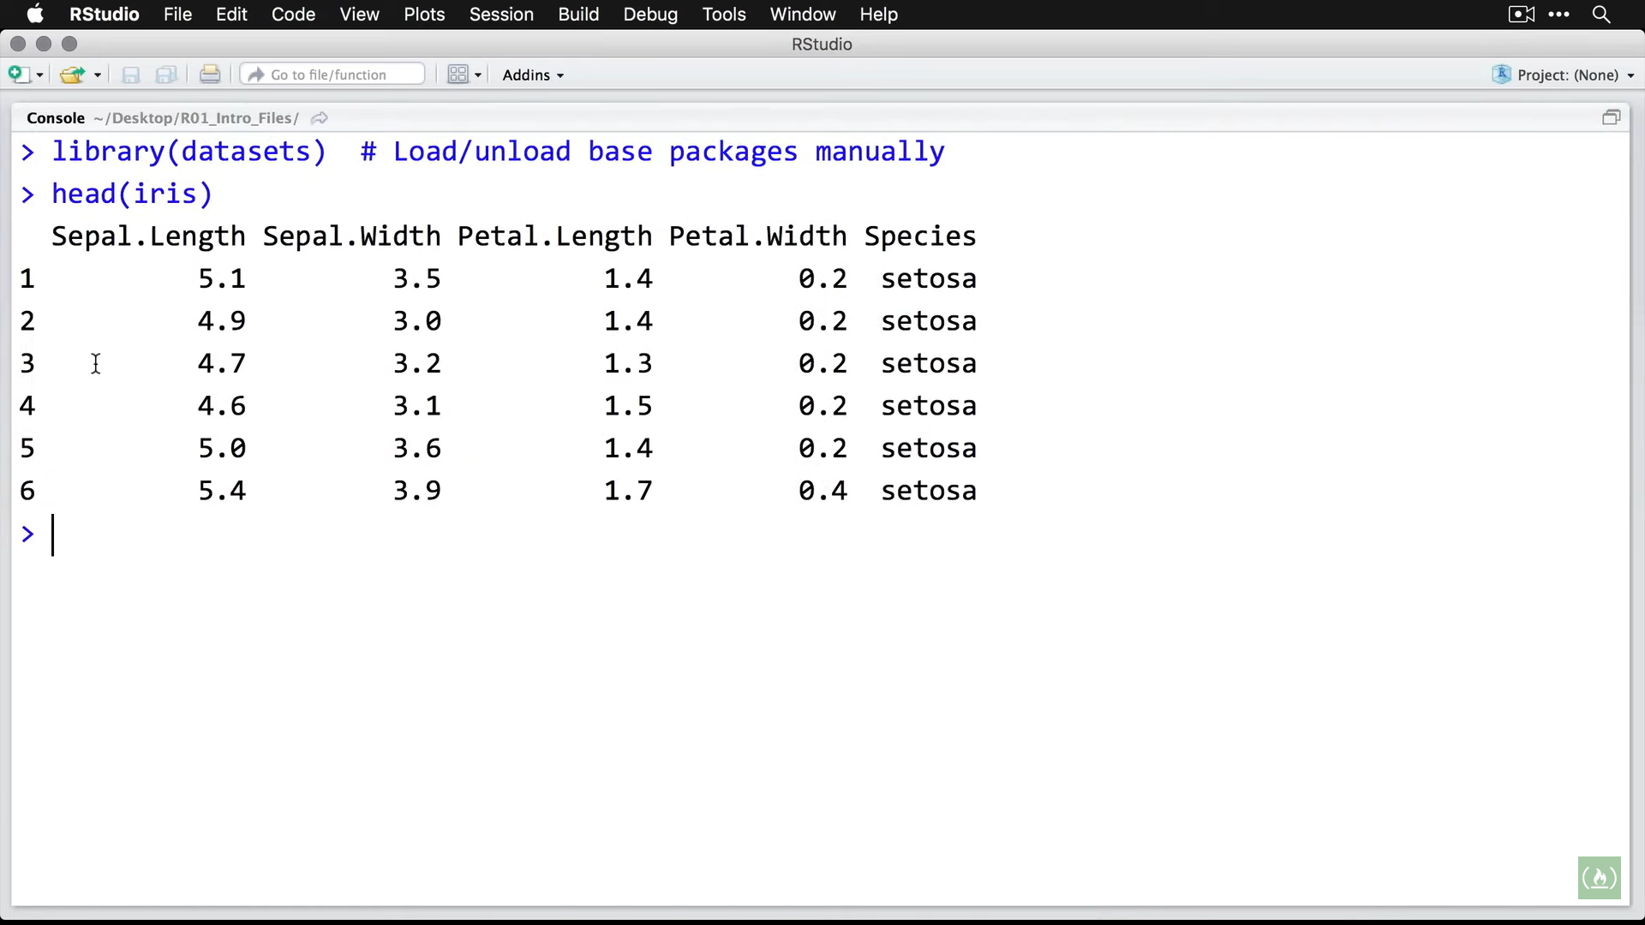

Shows measurement of sepal & petal length and width for 3 species of iris flower.

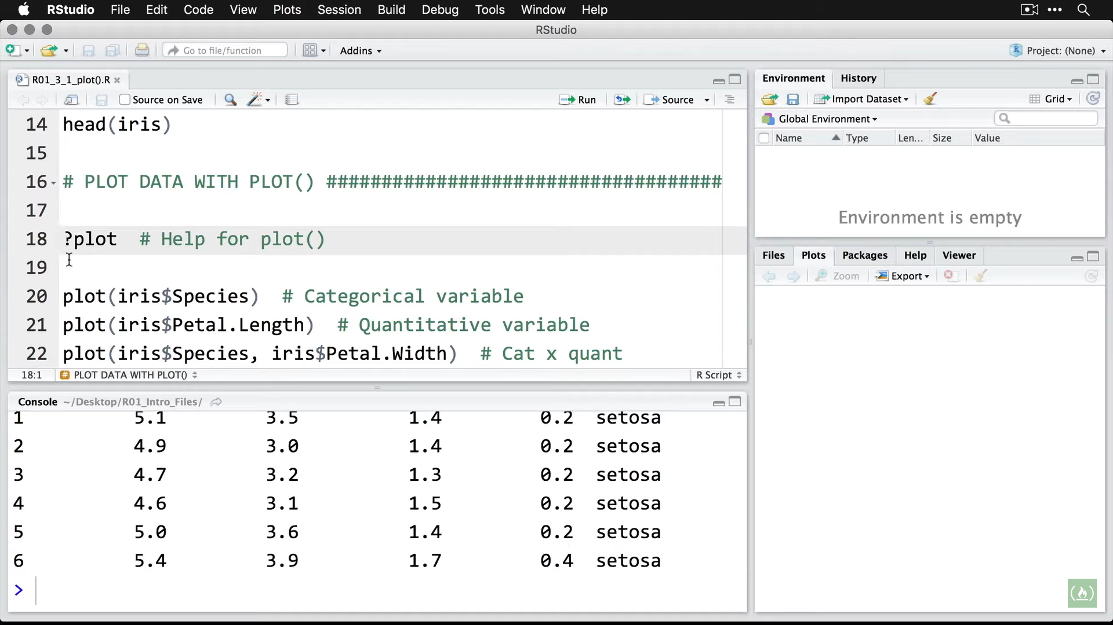

?xxxx shows the help for

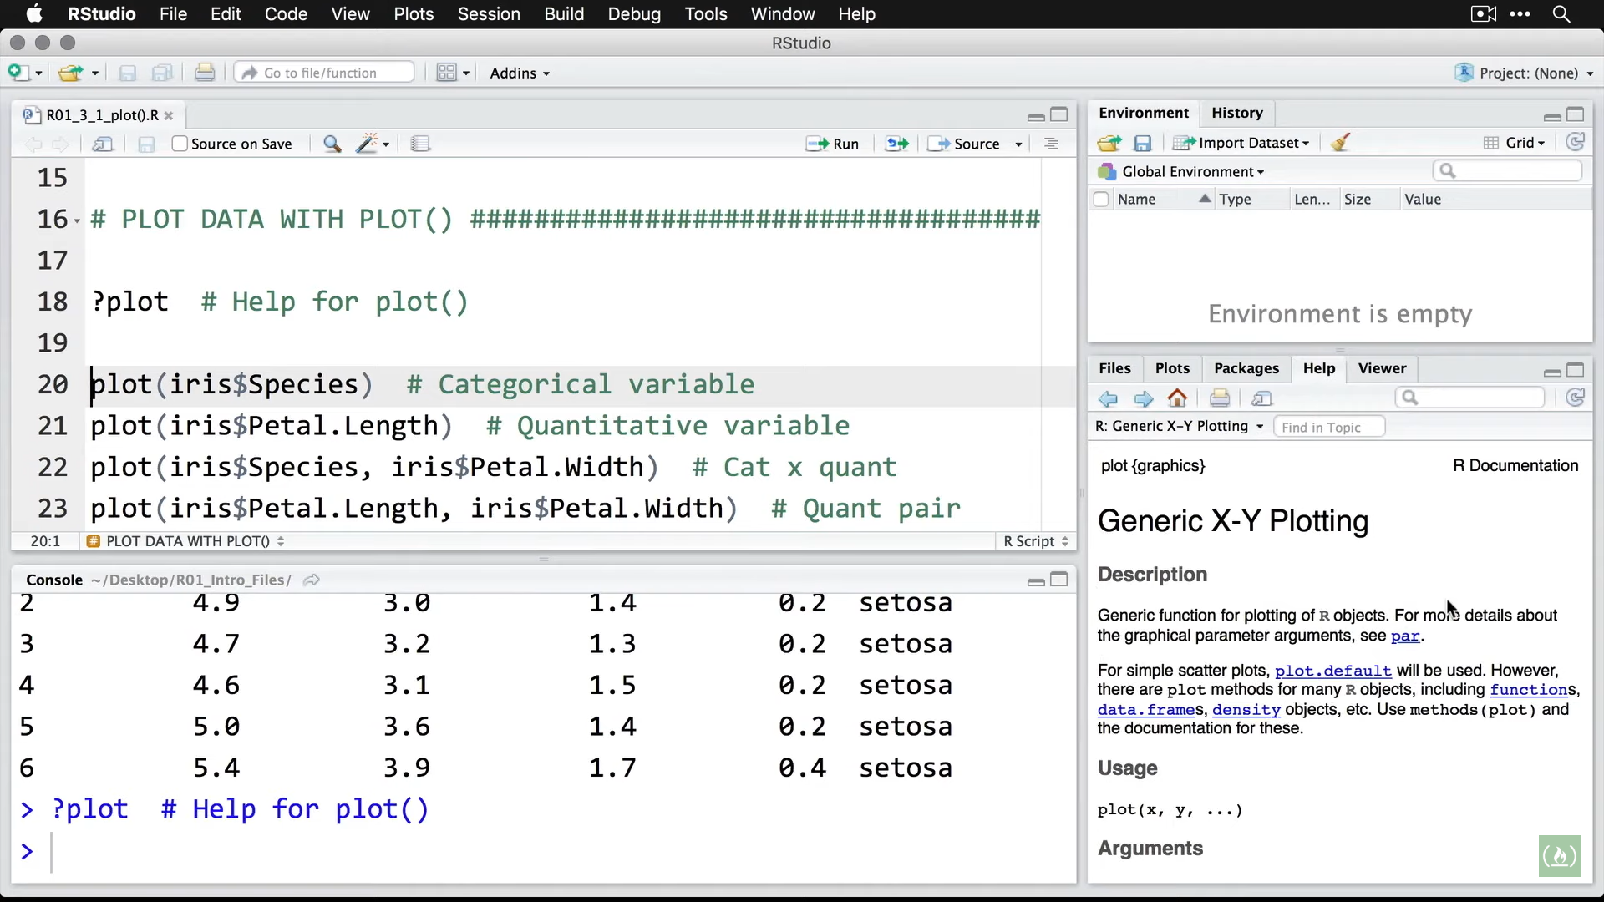

Plotting for a categorical variable (Species) from our dataset

plot(iris$Species)

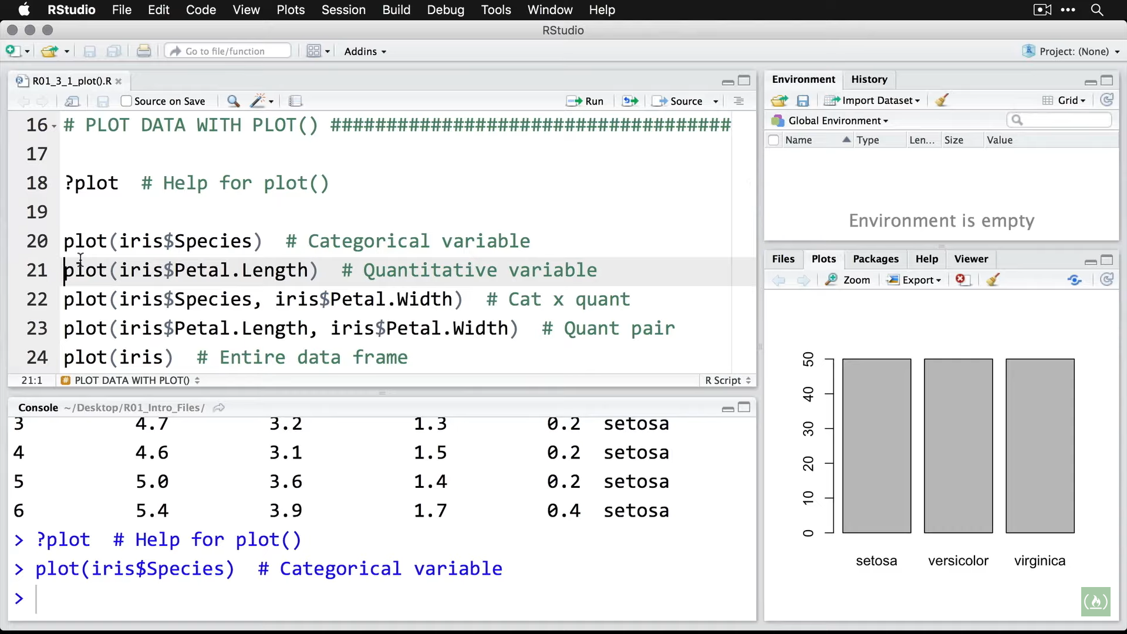

Shows the 3 species in the dataset

Now Looking at Petal Length

plot(iris$Petal.Length)

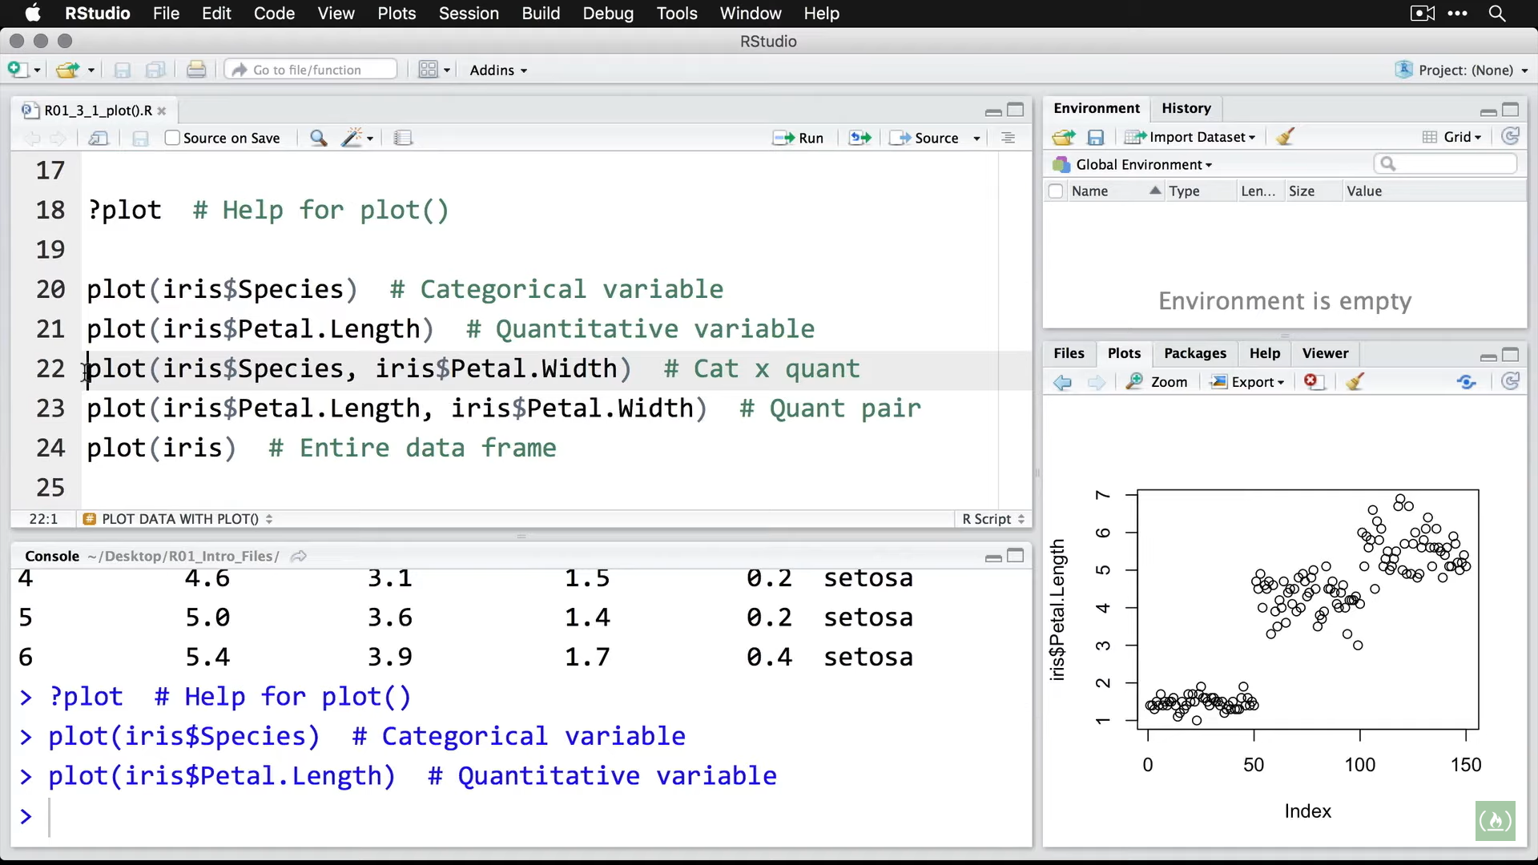

Zooming in shows

X axis: index number i.e. row number in dataset

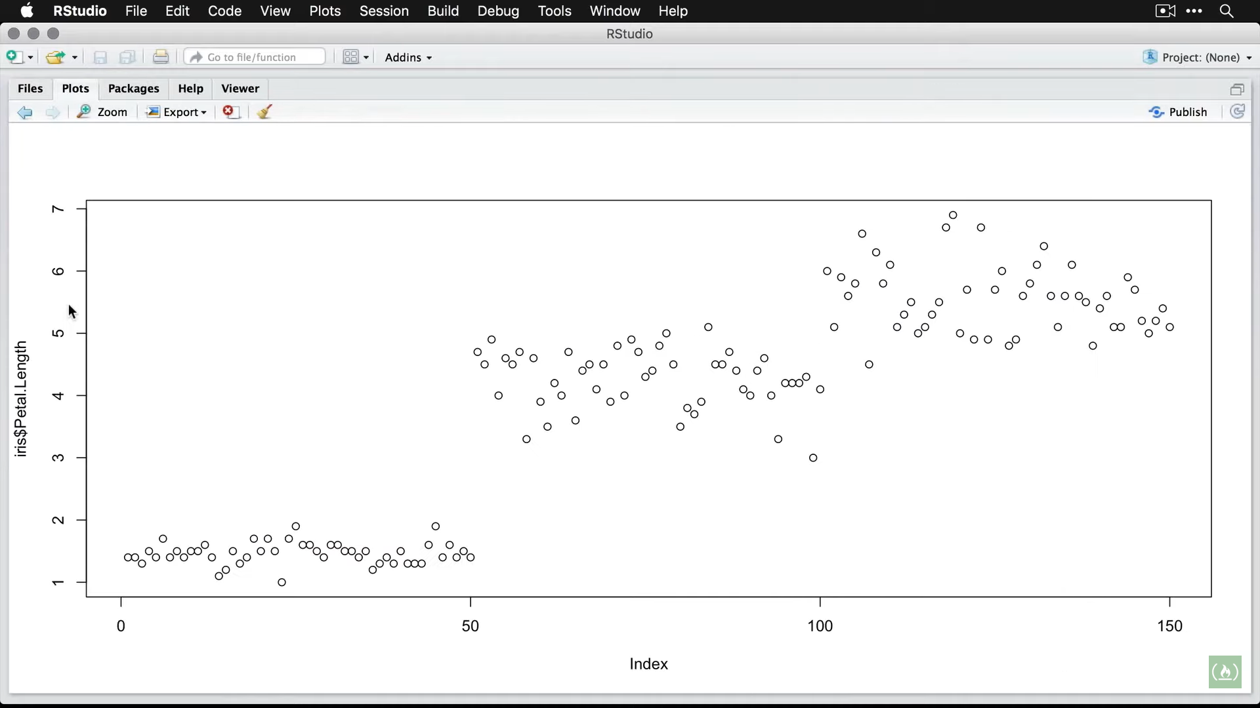

Now Looking at Species and Petal Width

plot(iris$Species, iris$Petal.Width)

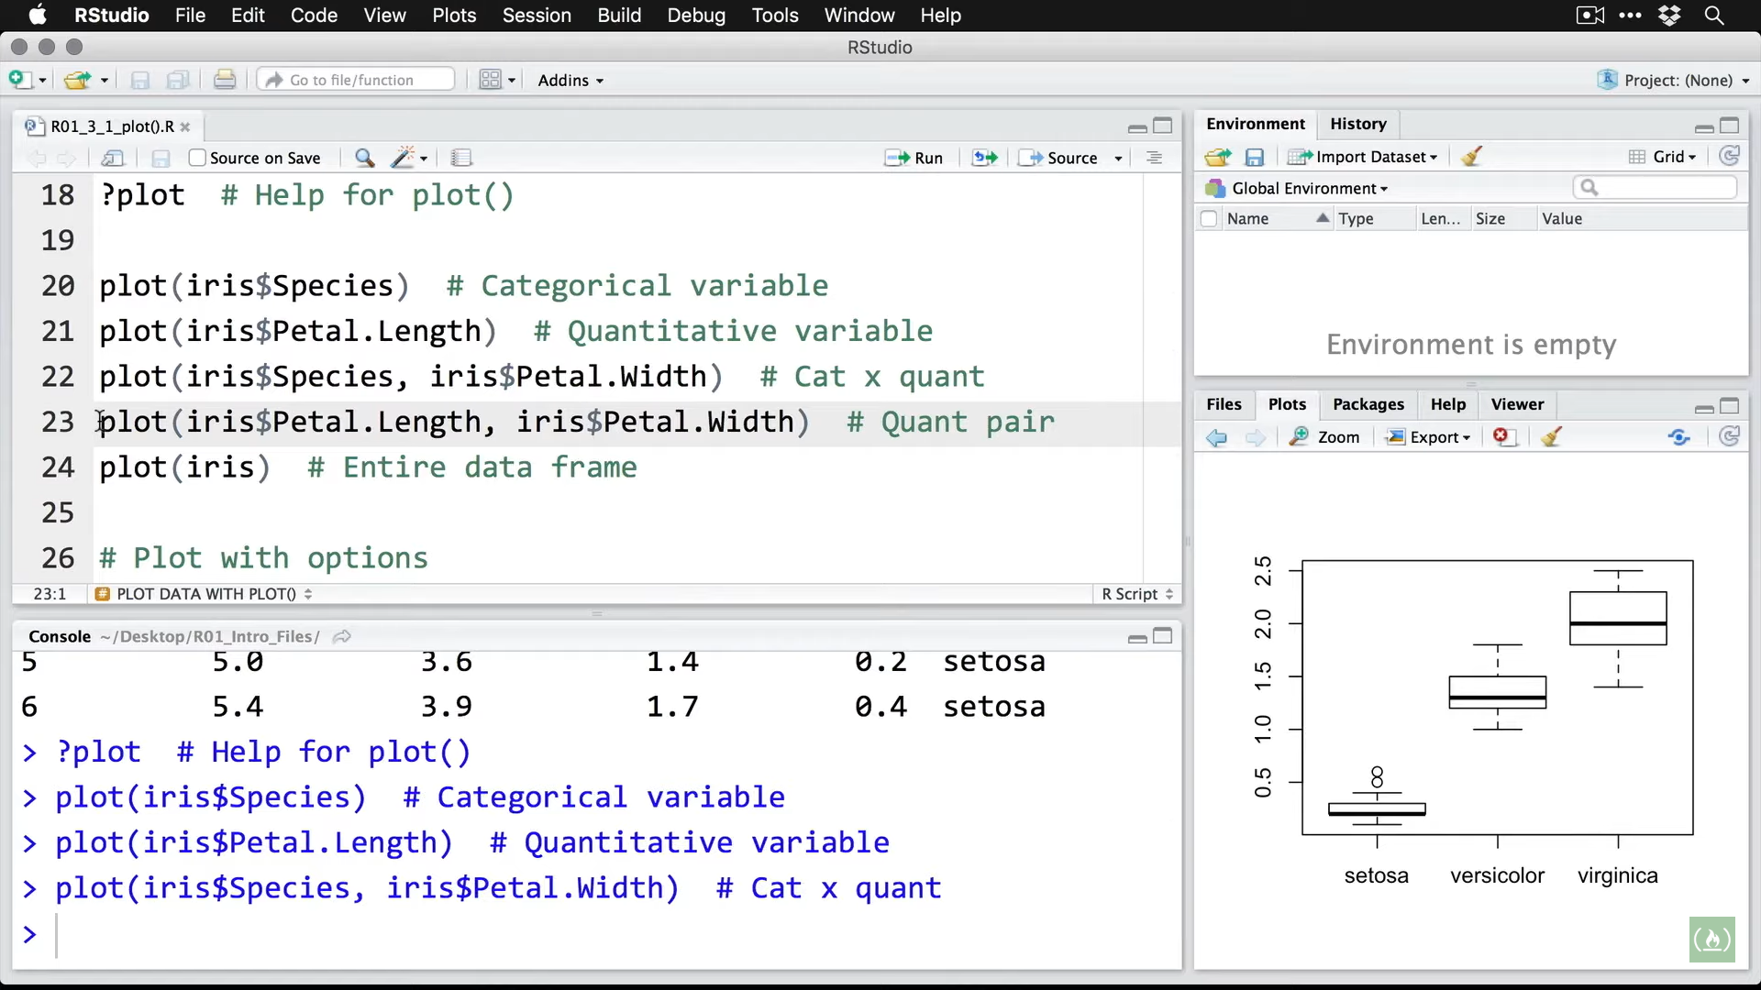

Zooming in shows variables

1.categorical 2. Quantitative

(Box plot is automatically chosen)

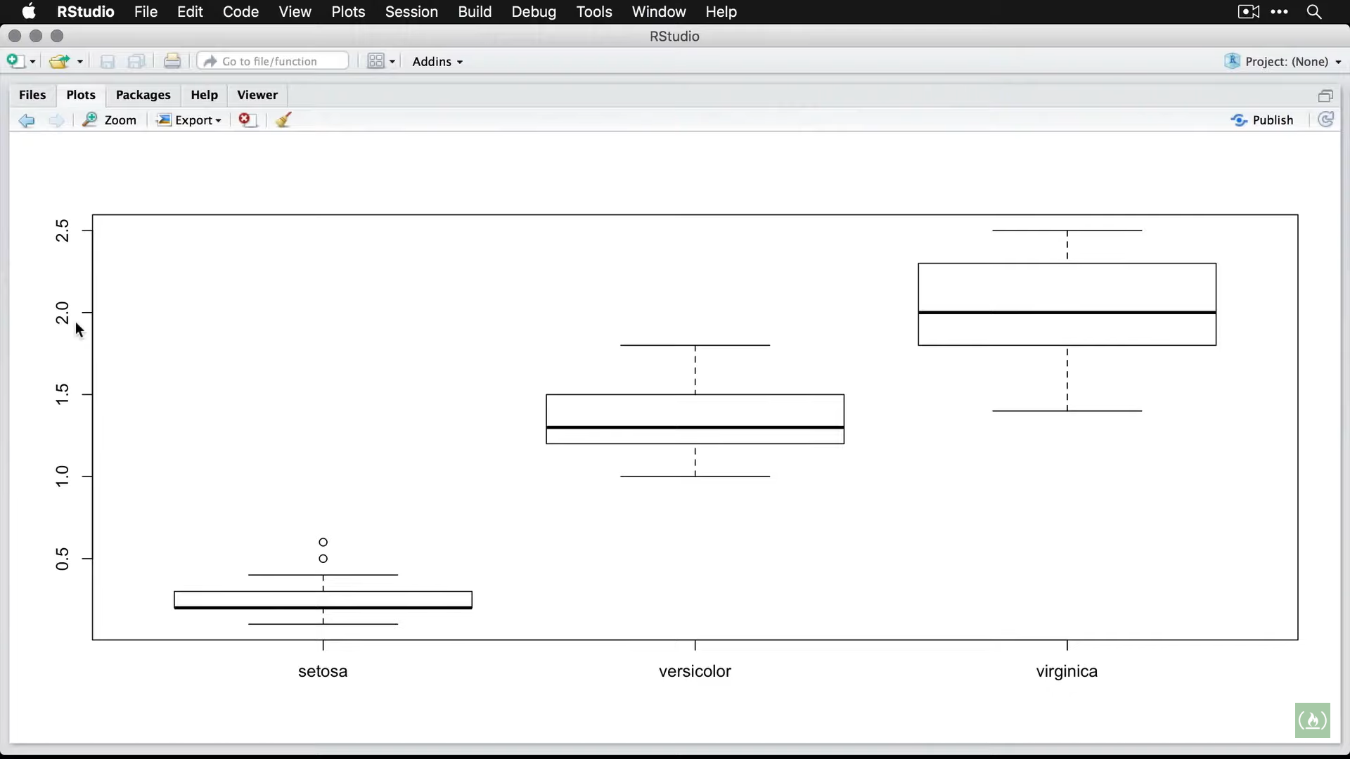

Now looking at a Quantitative Pair using

plot(iris$Petal.Length, iris$Petal.Width)

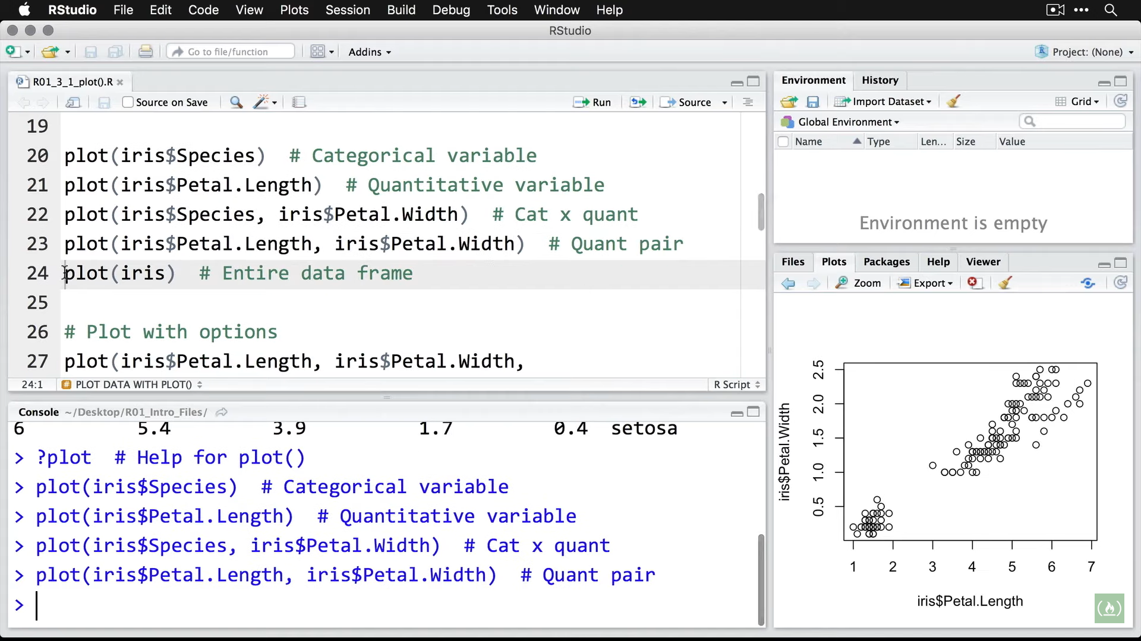

Zooming shows association between measurements on x and y axis(i.e. if a petal gets longer it gets wider i.e. overall bigger)

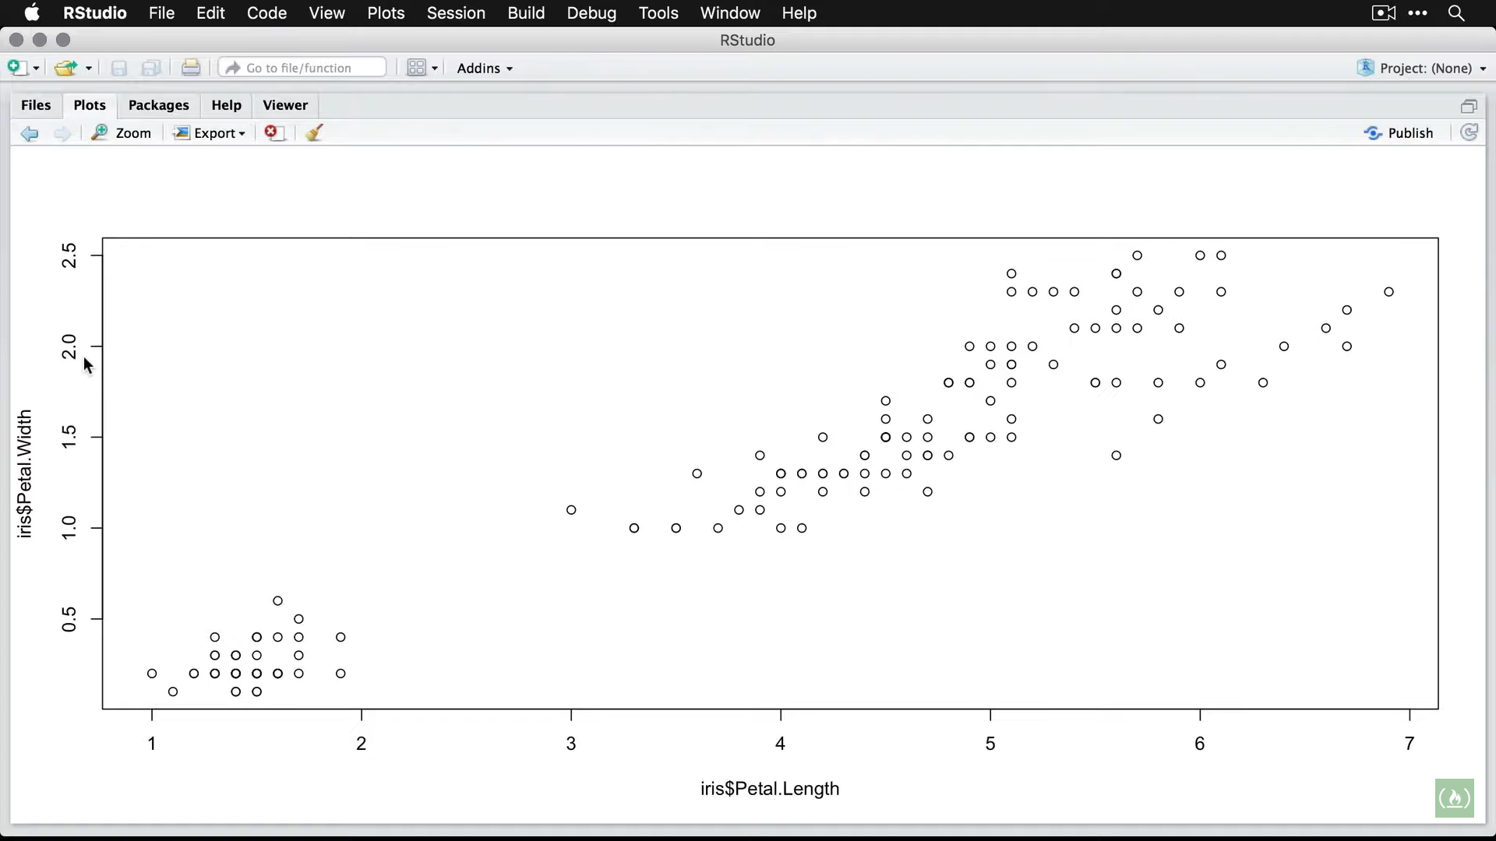

Plotting on entire dataset

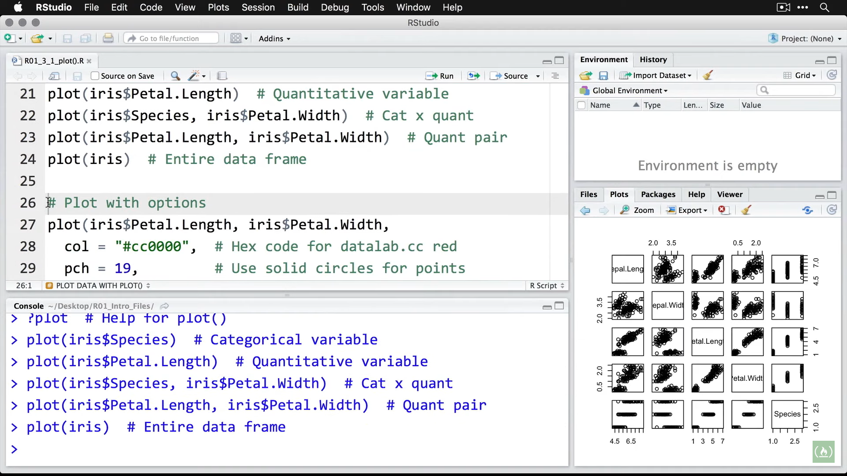

Zooming in shows a matrix of scatter plot for all 4 quantitative variables. It shows dot plot for measurement of each species

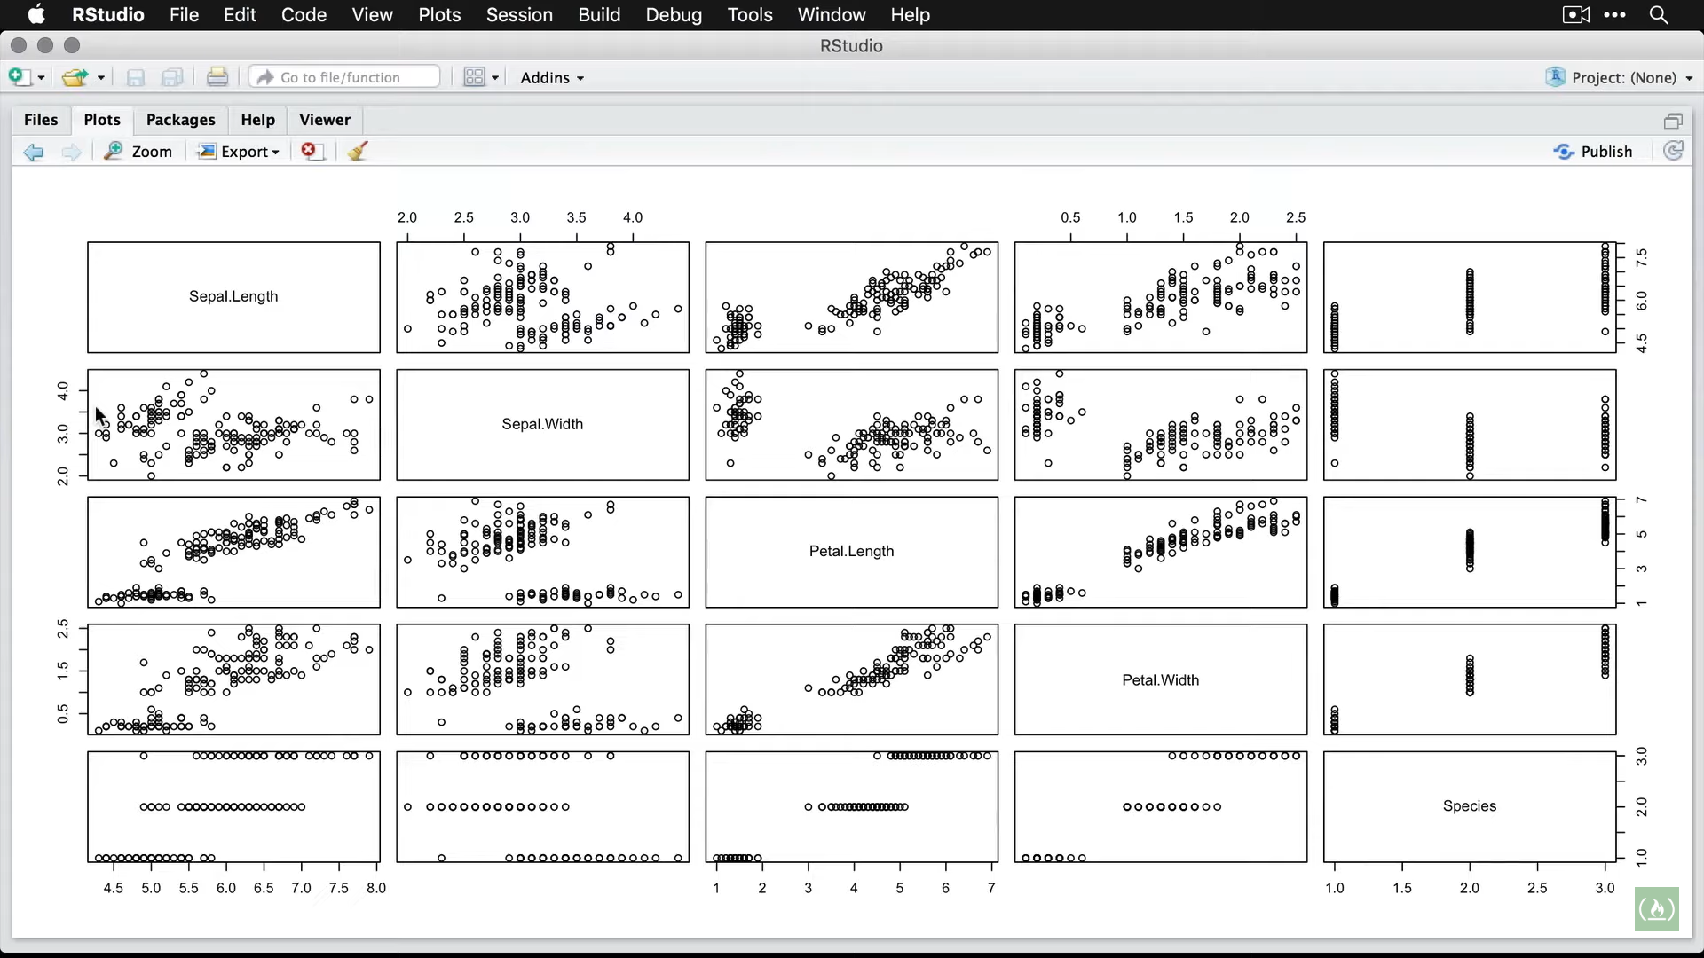

Options for plotting

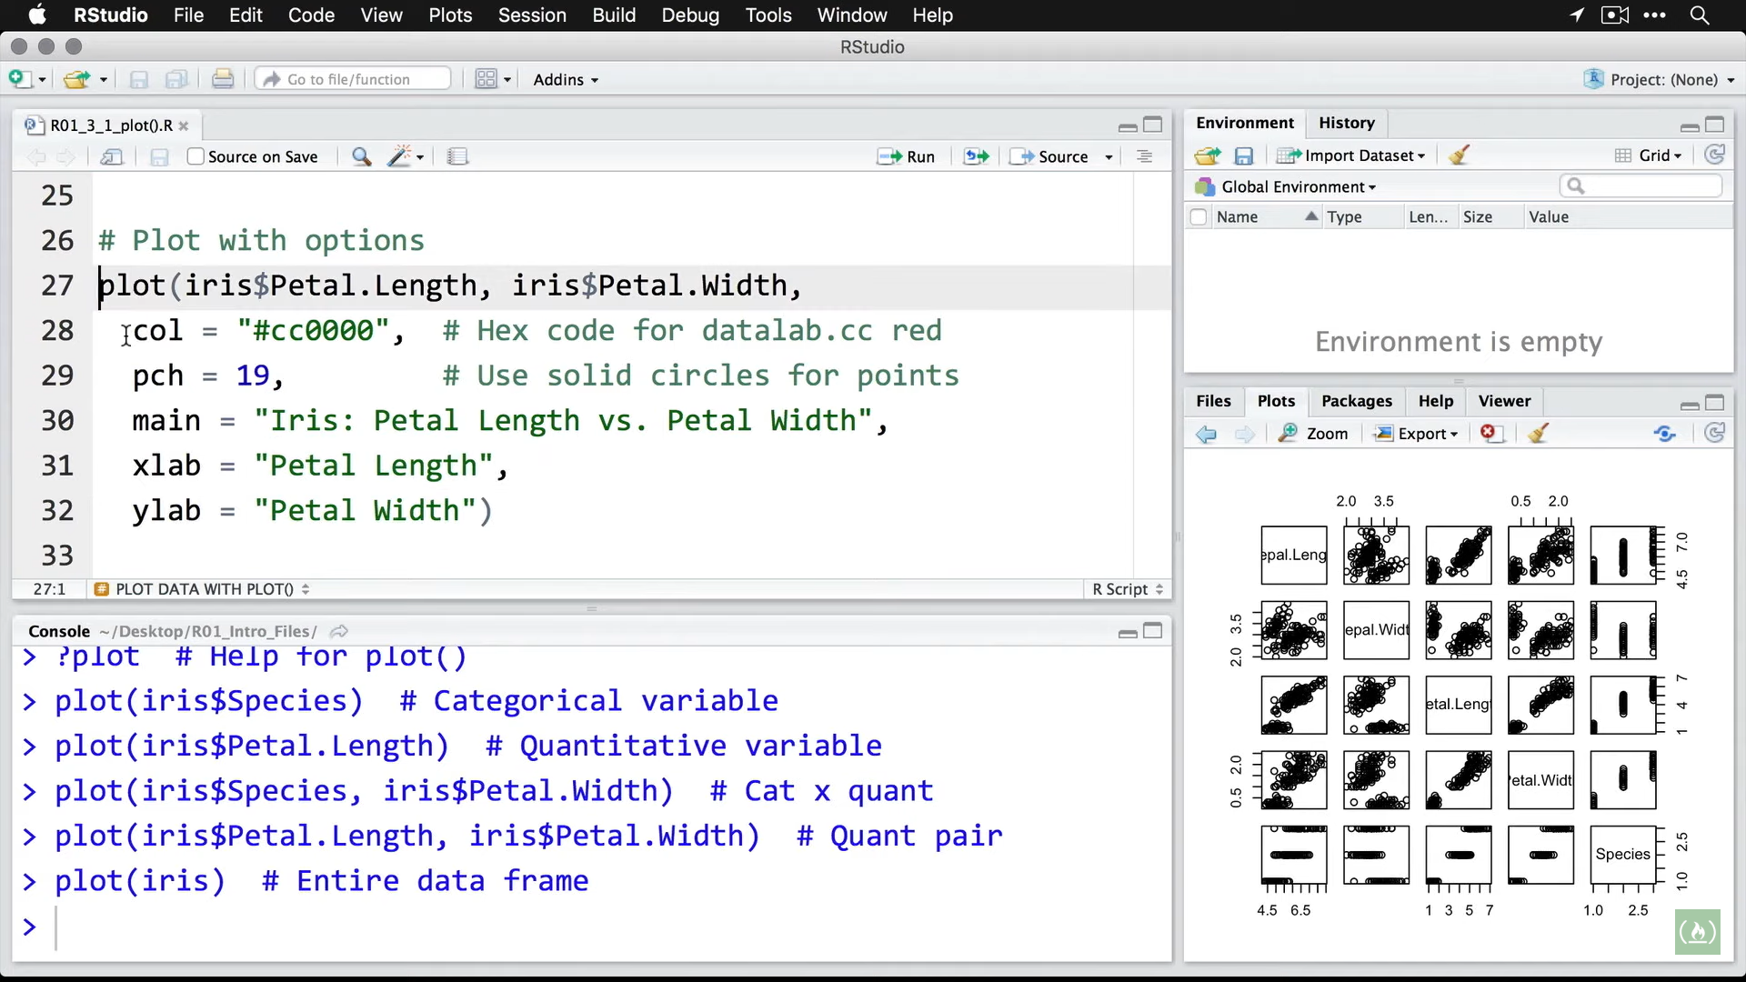

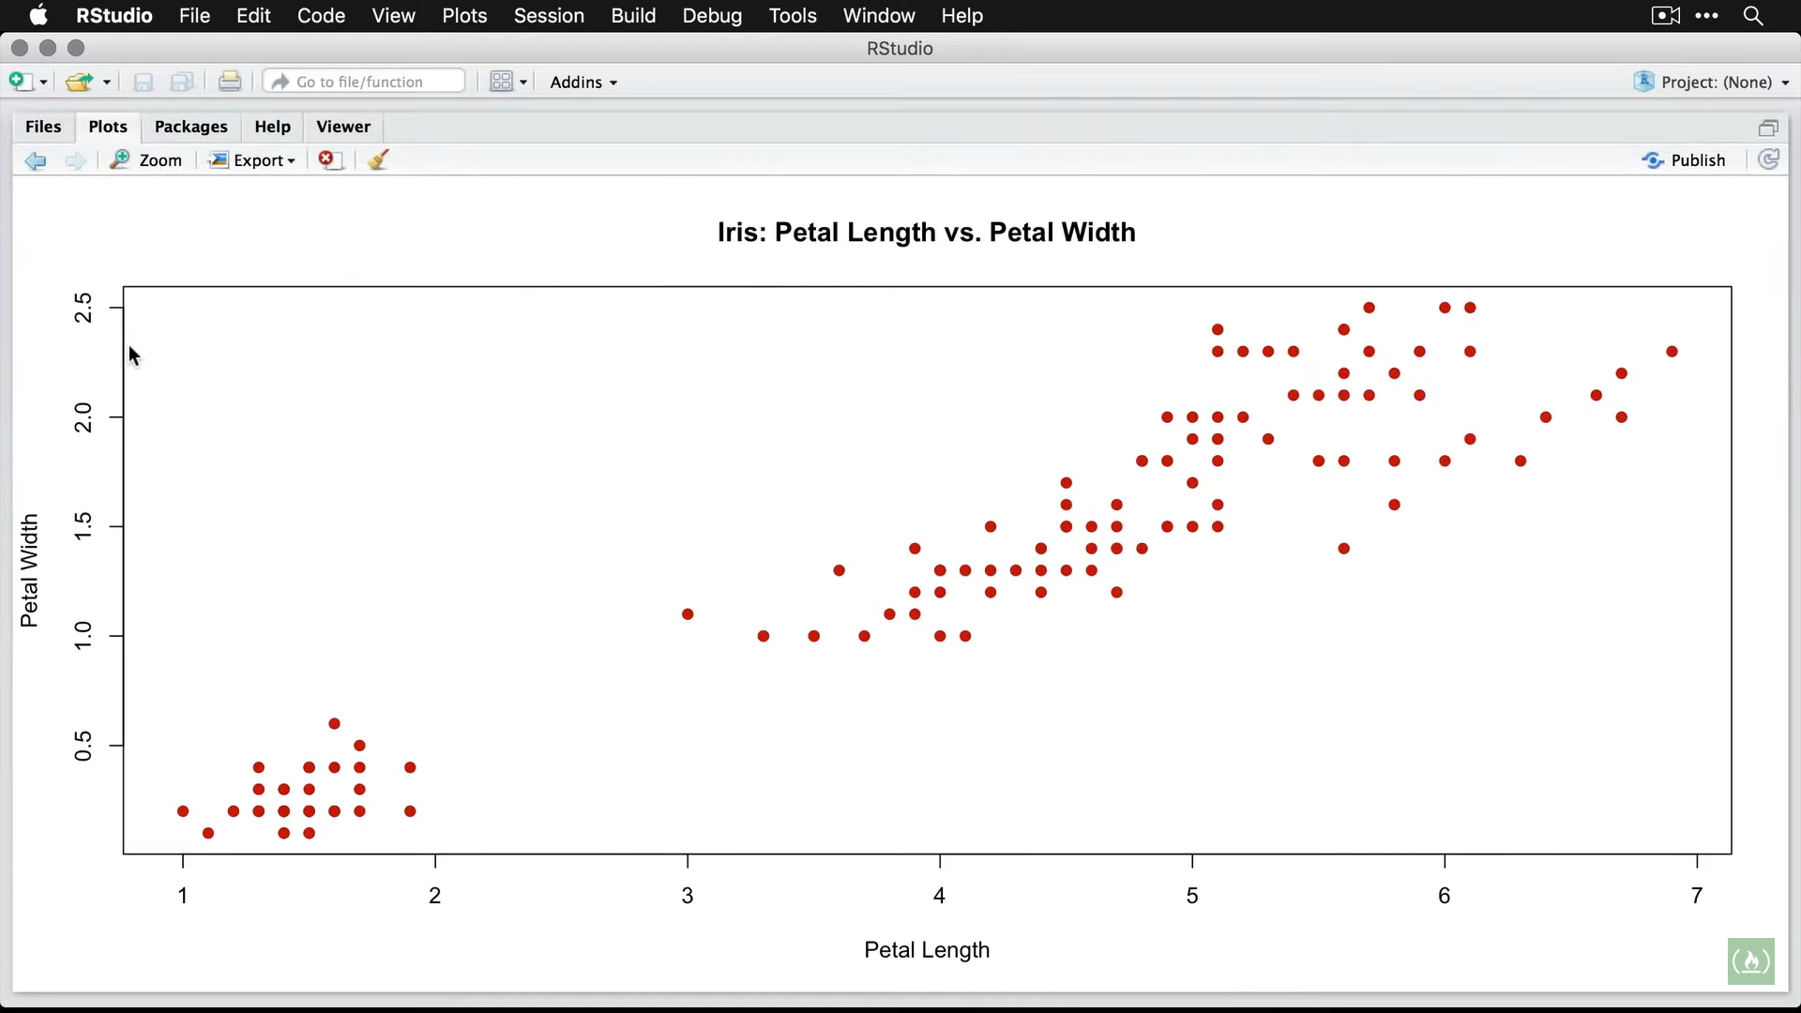

Passing in formulas to plot

Ex: getting a cosine curve

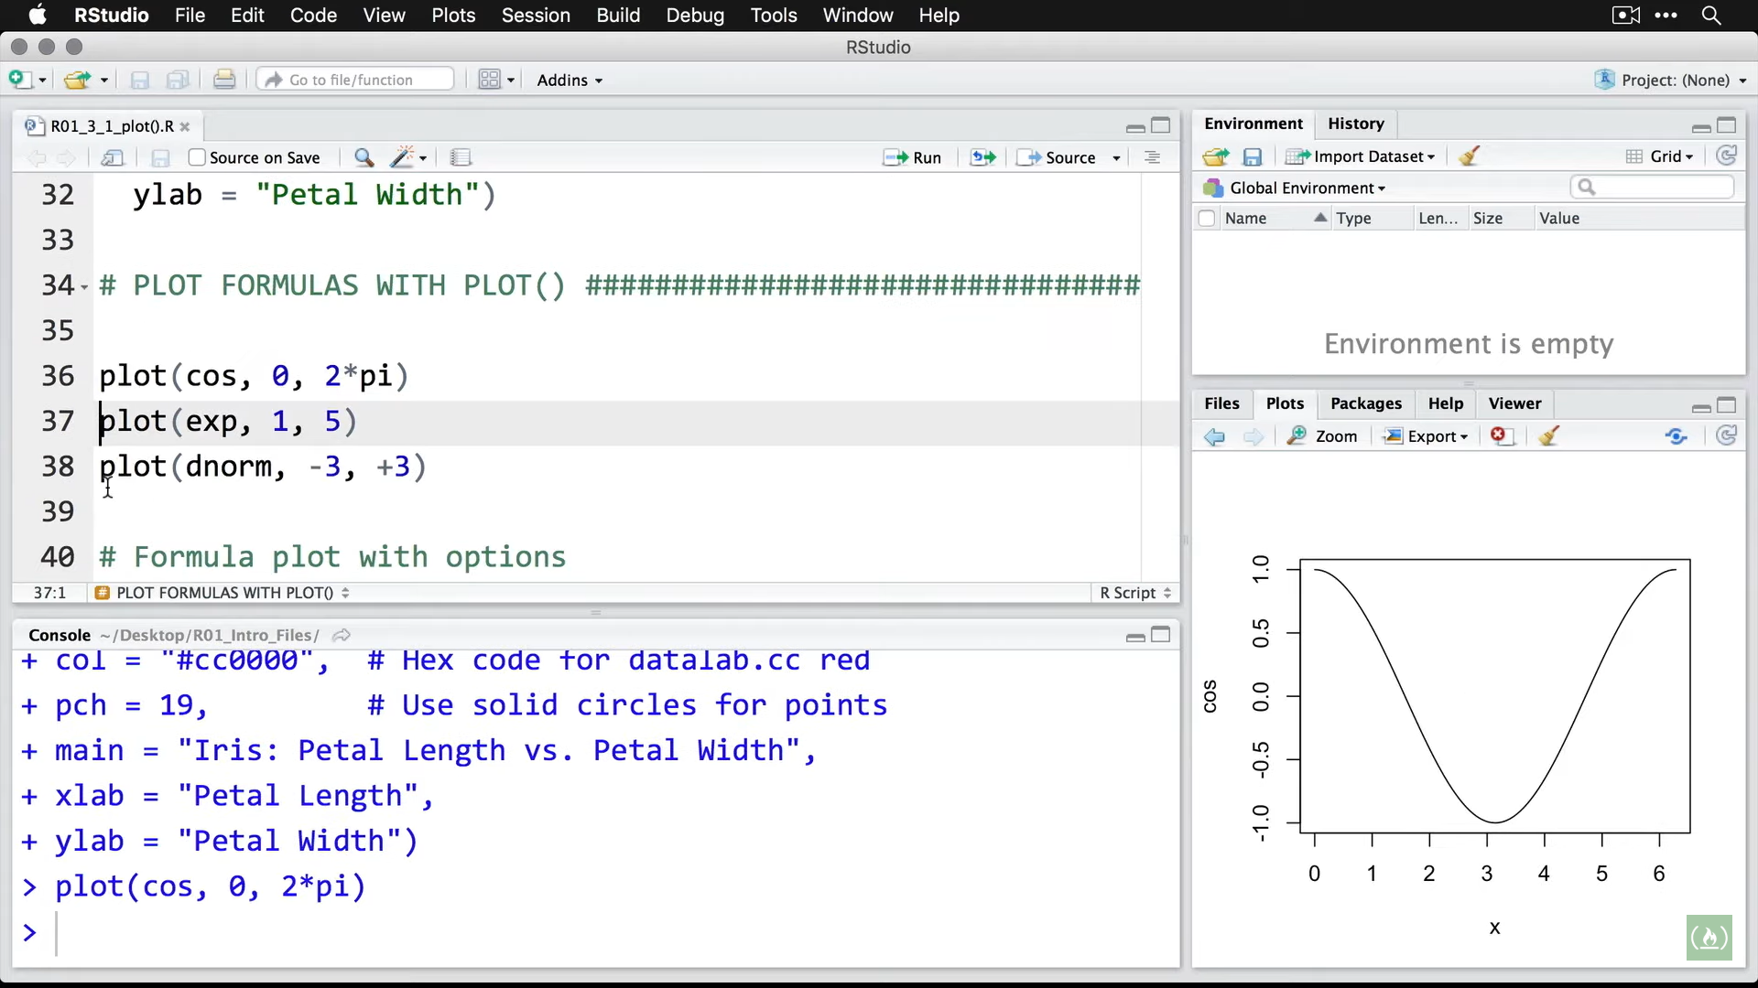

Getting an exponential distribution

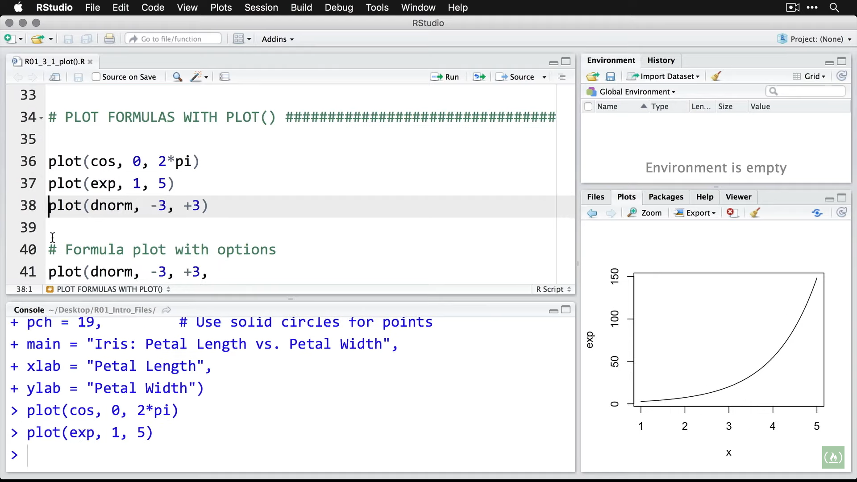

Getting density of normal distribution from -3 to +3

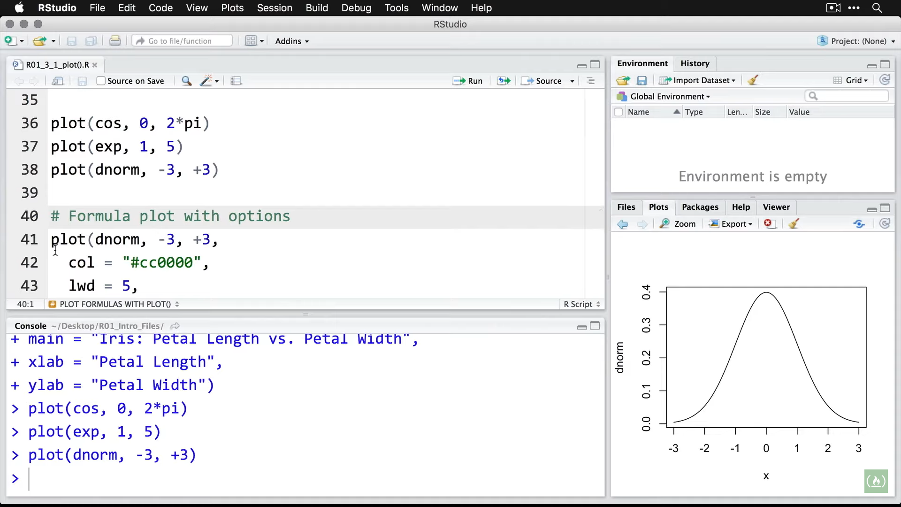

Passing options to plot

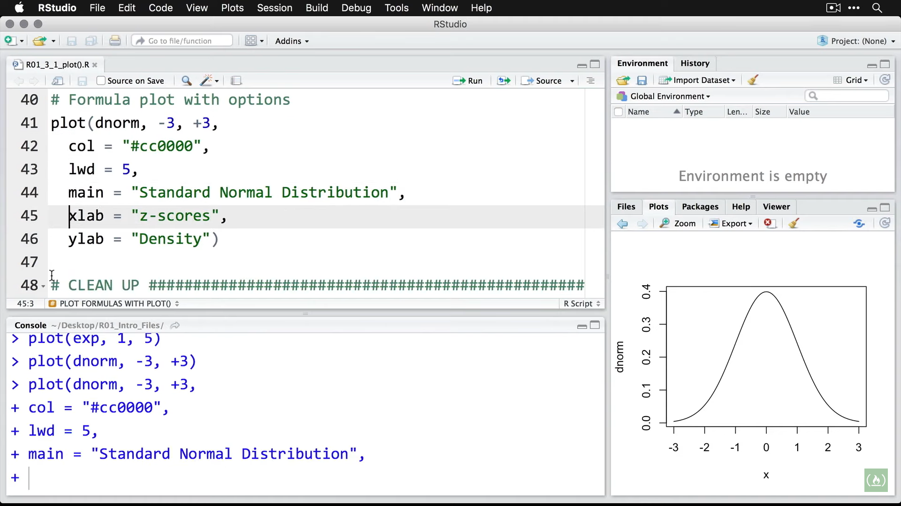

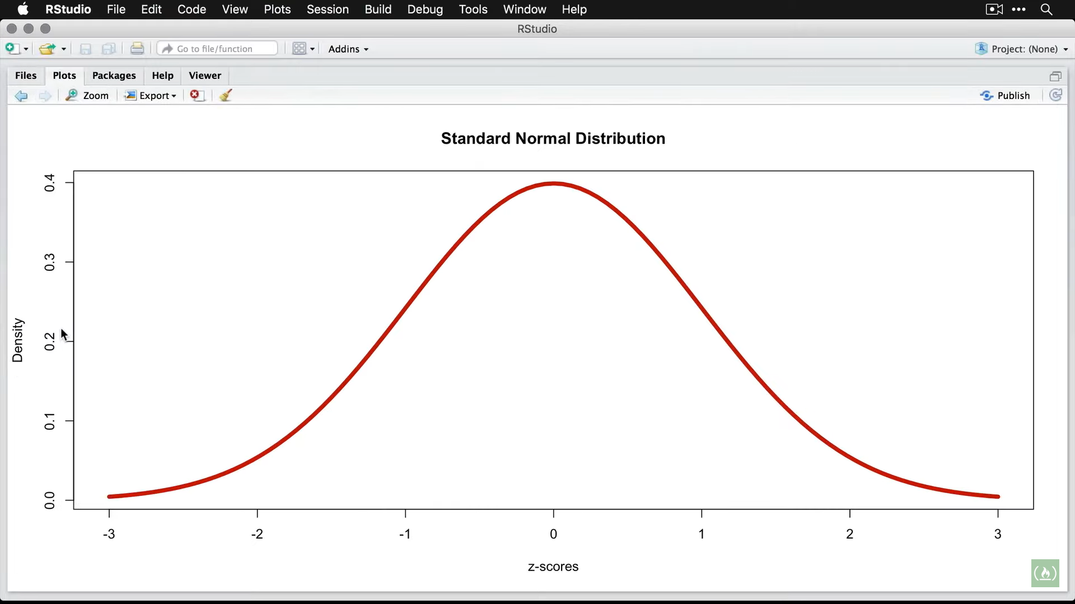

**Bar Charts** (most basic graphic for most basic data)

**Installing packages**

> install.packages("pacman")

WARNING: Rtools is required to build R packages but is not currently installed. Please download and install the appropriate version of Rtools before proceeding:

https://cran.rstudio.com/bin/windows/Rtools/

Installing package into ‘C:/Users/Win10/Documents/R/win-library/3.6’

(as ‘lib’ is unspecified)

also installing the dependency ‘remotes’

trying URL 'https://cran.rstudio.com/bin/windows/contrib/3.6/remotes_2.1.0.zip'

Content type 'application/zip' length 354934 bytes (346 KB)

downloaded 346 KB

trying URL 'https://cran.rstudio.com/bin/windows/contrib/3.6/pacman_0.5.1.zip'

Content type 'application/zip' length 390078 bytes (380 KB)

downloaded 380 KB

package ‘remotes’ successfully unpacked and MD5 sums checked

package ‘pacman’ successfully unpacked and MD5 sums checked

The downloaded binary packages are in

C:\Users\Win10\AppData\Local\Temp\RtmpaKrFTl\downloaded_packages

> # Then load the package by using either of the following:

> require(pacman) # Gives a confirmation message.

Loading required package: pacman

> # Or, by using "pacman::p_load" you can use the p_load

> # function from pacman without actually loading pacman.

> # These are packages I load every time.

> pacman::p_load(pacman, dplyr, GGally, ggplot2, ggthemes,

+ ggvis, httr, lubridate, plotly, rio, rmarkdown, shiny,

+ stringr, tidyr)

Installing package into ‘C:/Users/Win10/Documents/R/win-library/3.6’

(as ‘lib’ is unspecified)

also installing the dependencies ‘backports’, ‘ellipsis’, ‘digest’, ‘zeallot’, ‘utf8’, ‘vctrs’, ‘cli’, ‘crayon’, ‘fansi’, ‘pillar’, ‘purrr’, ‘assertthat’, ‘glue’, ‘magrittr’, ‘pkgconfig’, ‘R6’, ‘Rcpp’, ‘rlang’, ‘tibble’, ‘tidyselect’, ‘BH’, ‘plogr’

Warning: unable to access index for repository http://www.stats.ox.ac.uk/pub/RWin/bin/windows/contrib/3.6:

cannot open URL 'http://www.stats.ox.ac.uk/pub/RWin/bin/windows/contrib/3.6/PACKAGES'

trying URL 'https://cran.rstudio.com/bin/windows/contrib/3.6/backports_1.1.5.zip'

Content type 'application/zip' length 68649 bytes (67 KB)

downloaded 67 KB

trying URL 'https://cran.rstudio.com/bin/windows/contrib/3.6/ellipsis_0.3.0.zip'

Content type 'application/zip' length 44612 bytes (43 KB)

downloaded 43 KB

trying URL 'https://cran.rstudio.com/bin/windows/contrib/3.6/digest_0.6.23.zip'

Content type 'application/zip' length 249147 bytes (243 KB)

downloaded 243 KB

trying URL 'https://cran.rstudio.com/bin/windows/contrib/3.6/zeallot_0.1.0.zip'

Content type 'application/zip' length 62200 bytes (60 KB)

downloaded 60 KB

trying URL 'https://cran.rstudio.com/bin/windows/contrib/3.6/utf8_1.1.4.zip'

Content type 'application/zip' length 215092 bytes (210 KB)

downloaded 210 KB

trying URL 'https://cran.rstudio.com/bin/windows/contrib/3.6/vctrs_0.2.1.zip'

Content type 'application/zip' length 829966 bytes (810 KB)

downloaded 810 KB

trying URL 'https://cran.rstudio.com/bin/windows/contrib/3.6/cli_2.0.0.zip'

Content type 'application/zip' length 392235 bytes (383 KB)

downloaded 383 KB

trying URL 'https://cran.rstudio.com/bin/windows/contrib/3.6/crayon_1.3.4.zip'

Content type 'application/zip' length 750390 bytes (732 KB)

downloaded 732 KB

trying URL 'https://cran.rstudio.com/bin/windows/contrib/3.6/fansi_0.4.0.zip'

Content type 'application/zip' length 221415 bytes (216 KB)

downloaded 216 KB

trying URL 'https://cran.rstudio.com/bin/windows/contrib/3.6/pillar_1.4.3.zip'

Content type 'application/zip' length 184800 bytes (180 KB)

downloaded 180 KB

trying URL 'https://cran.rstudio.com/bin/windows/contrib/3.6/purrr_0.3.3.zip'

Content type 'application/zip' length 426544 bytes (416 KB)

downloaded 416 KB

trying URL 'https://cran.rstudio.com/bin/windows/contrib/3.6/assertthat_0.2.1.zip'

Content type 'application/zip' length 55142 bytes (53 KB)

downloaded 53 KB

trying URL 'https://cran.rstudio.com/bin/windows/contrib/3.6/glue_1.3.1.zip'

Content type 'application/zip' length 173411 bytes (169 KB)

downloaded 169 KB

trying URL 'https://cran.rstudio.com/bin/windows/contrib/3.6/magrittr_1.5.zip'

Content type 'application/zip' length 157802 bytes (154 KB)

downloaded 154 KB

trying URL 'https://cran.rstudio.com/bin/windows/contrib/3.6/pkgconfig_2.0.3.zip'

Content type 'application/zip' length 22449 bytes (21 KB)

downloaded 21 KB

trying URL 'https://cran.rstudio.com/bin/windows/contrib/3.6/R6_2.4.1.zip'

Content type 'application/zip' length 59304 bytes (57 KB)

downloaded 57 KB

trying URL 'https://cran.rstudio.com/bin/windows/contrib/3.6/Rcpp_1.0.3.zip'

Content type 'application/zip' length 2990011 bytes (2.9 MB)

downloaded 2.9 MB

trying URL 'https://cran.rstudio.com/bin/windows/contrib/3.6/rlang_0.4.2.zip'

Content type 'application/zip' length 1113533 bytes (1.1 MB)

downloaded 1.1 MB

trying URL 'https://cran.rstudio.com/bin/windows/contrib/3.6/tibble_2.1.3.zip'

Content type 'application/zip' length 336880 bytes (328 KB)

downloaded 328 KB

trying URL 'https://cran.rstudio.com/bin/windows/contrib/3.6/tidyselect_0.2.5.zip'

Content type 'application/zip' length 624444 bytes (609 KB)

downloaded 609 KB

trying URL 'https://cran.rstudio.com/bin/windows/contrib/3.6/BH_1.72.0-2.zip'

Content type 'application/zip' length 18170821 bytes (17.3 MB)

downloaded 17.3 MB

trying URL 'https://cran.rstudio.com/bin/windows/contrib/3.6/plogr_0.2.0.zip'

Content type 'application/zip' length 18878 bytes (18 KB)

downloaded 18 KB

trying URL 'https://cran.rstudio.com/bin/windows/contrib/3.6/dplyr_0.8.3.zip'

Content type 'application/zip' length 3225196 bytes (3.1 MB)

downloaded 3.1 MB

package ‘backports’ successfully unpacked and MD5 sums checked

package ‘ellipsis’ successfully unpacked and MD5 sums checked

package ‘digest’ successfully unpacked and MD5 sums checked

package ‘zeallot’ successfully unpacked and MD5 sums checked

package ‘utf8’ successfully unpacked and MD5 sums checked

package ‘vctrs’ successfully unpacked and MD5 sums checked

package ‘cli’ successfully unpacked and MD5 sums checked

package ‘crayon’ successfully unpacked and MD5 sums checked

package ‘fansi’ successfully unpacked and MD5 sums checked

package ‘pillar’ successfully unpacked and MD5 sums checked

package ‘purrr’ successfully unpacked and MD5 sums checked

package ‘assertthat’ successfully unpacked and MD5 sums checked

package ‘glue’ successfully unpacked and MD5 sums checked

package ‘magrittr’ successfully unpacked and MD5 sums checked

package ‘pkgconfig’ successfully unpacked and MD5 sums checked

package ‘R6’ successfully unpacked and MD5 sums checked

package ‘Rcpp’ successfully unpacked and MD5 sums checked

package ‘rlang’ successfully unpacked and MD5 sums checked

package ‘tibble’ successfully unpacked and MD5 sums checked

package ‘tidyselect’ successfully unpacked and MD5 sums checked

package ‘BH’ successfully unpacked and MD5 sums checked

package ‘plogr’ successfully unpacked and MD5 sums checked

package ‘dplyr’ successfully unpacked and MD5 sums checked

The downloaded binary packages are in

C:\Users\Win10\AppData\Local\Temp\RtmpaKrFTl\downloaded_packages

dplyr installed

Installing package into ‘C:/Users/Win10/Documents/R/win-library/3.6’

(as ‘lib’ is unspecified)

also installing the dependencies ‘stringi’, ‘colorspace’, ‘stringr’, ‘farver’, ‘labeling’, ‘munsell’, ‘lifecycle’, ‘lazyeval’, ‘reshape2’, ‘scales’, ‘viridisLite’, ‘withr’, ‘hms’, ‘prettyunits’, ‘ggplot2’, ‘gtable’, ‘plyr’, ‘progress’, ‘RColorBrewer’, ‘reshape’

Warning: unable to access index for repository http://www.stats.ox.ac.uk/pub/RWin/bin/windows/contrib/3.6:

cannot open URL 'http://www.stats.ox.ac.uk/pub/RWin/bin/windows/contrib/3.6/PACKAGES'

trying URL 'https://cran.rstudio.com/bin/windows/contrib/3.6/stringi_1.4.3.zip'

Content type 'application/zip' length 15297905 bytes (14.6 MB)

downloaded 14.6 MB

trying URL 'https://cran.rstudio.com/bin/windows/contrib/3.6/colorspace_1.4-1.zip'

Content type 'application/zip' length 2550276 bytes (2.4 MB)

downloaded 2.4 MB

trying URL 'https://cran.rstudio.com/bin/windows/contrib/3.6/stringr_1.4.0.zip'

Content type 'application/zip' length 216916 bytes (211 KB)

downloaded 211 KB

trying URL 'https://cran.rstudio.com/bin/windows/contrib/3.6/farver_2.0.1.zip'

Content type 'application/zip' length 1899789 bytes (1.8 MB)

downloaded 1.8 MB

trying URL 'https://cran.rstudio.com/bin/windows/contrib/3.6/labeling_0.3.zip'

Content type 'application/zip' length 62937 bytes (61 KB)

downloaded 61 KB

trying URL 'https://cran.rstudio.com/bin/windows/contrib/3.6/munsell_0.5.0.zip'

Content type 'application/zip' length 246132 bytes (240 KB)

downloaded 240 KB

trying URL 'https://cran.rstudio.com/bin/windows/contrib/3.6/lifecycle_0.1.0.zip'

Content type 'application/zip' length 84781 bytes (82 KB)

downloaded 82 KB

trying URL 'https://cran.rstudio.com/bin/windows/contrib/3.6/lazyeval_0.2.2.zip'

Content type 'application/zip' length 173482 bytes (169 KB)

downloaded 169 KB

trying URL 'https://cran.rstudio.com/bin/windows/contrib/3.6/reshape2_1.4.3.zip'

Content type 'application/zip' length 626557 bytes (611 KB)

downloaded 611 KB

trying URL 'https://cran.rstudio.com/bin/windows/contrib/3.6/scales_1.1.0.zip'

Content type 'application/zip' length 557267 bytes (544 KB)

downloaded 544 KB

trying URL 'https://cran.rstudio.com/bin/windows/contrib/3.6/viridisLite_0.3.0.zip'

Content type 'application/zip' length 60760 bytes (59 KB)

downloaded 59 KB

trying URL 'https://cran.rstudio.com/bin/windows/contrib/3.6/withr_2.1.2.zip'

Content type 'application/zip' length 152109 bytes (148 KB)

downloaded 148 KB

trying URL 'https://cran.rstudio.com/bin/windows/contrib/3.6/hms_0.5.2.zip'

Content type 'application/zip' length 111706 bytes (109 KB)

downloaded 109 KB

trying URL 'https://cran.rstudio.com/bin/windows/contrib/3.6/prettyunits_1.0.2.zip'

Content type 'application/zip' length 33612 bytes (32 KB)

downloaded 32 KB

trying URL 'https://cran.rstudio.com/bin/windows/contrib/3.6/ggplot2_3.2.1.zip'

Content type 'application/zip' length 3976553 bytes (3.8 MB)

downloaded 3.8 MB

trying URL 'https://cran.rstudio.com/bin/windows/contrib/3.6/gtable_0.3.0.zip'

Content type 'application/zip' length 434596 bytes (424 KB)

downloaded 424 KB

trying URL 'https://cran.rstudio.com/bin/windows/contrib/3.6/plyr_1.8.5.zip'

Content type 'application/zip' length 1305422 bytes (1.2 MB)

downloaded 1.2 MB

trying URL 'https://cran.rstudio.com/bin/windows/contrib/3.6/progress_1.2.2.zip'

Content type 'application/zip' length 85685 bytes (83 KB)

downloaded 83 KB

trying URL 'https://cran.rstudio.com/bin/windows/contrib/3.6/RColorBrewer_1.1-2.zip'

Content type 'application/zip' length 55569 bytes (54 KB)

downloaded 54 KB

trying URL 'https://cran.rstudio.com/bin/windows/contrib/3.6/reshape_0.8.8.zip'

Content type 'application/zip' length 171259 bytes (167 KB)

downloaded 167 KB

trying URL 'https://cran.rstudio.com/bin/windows/contrib/3.6/GGally_1.4.0.zip'

Content type 'application/zip' length 1442072 bytes (1.4 MB)

downloaded 1.4 MB

package ‘stringi’ successfully unpacked and MD5 sums checked

package ‘colorspace’ successfully unpacked and MD5 sums checked

package ‘stringr’ successfully unpacked and MD5 sums checked

package ‘farver’ successfully unpacked and MD5 sums checked

package ‘labeling’ successfully unpacked and MD5 sums checked

package ‘munsell’ successfully unpacked and MD5 sums checked

package ‘lifecycle’ successfully unpacked and MD5 sums checked

package ‘lazyeval’ successfully unpacked and MD5 sums checked

package ‘reshape2’ successfully unpacked and MD5 sums checked

package ‘scales’ successfully unpacked and MD5 sums checked

package ‘viridisLite’ successfully unpacked and MD5 sums checked

package ‘withr’ successfully unpacked and MD5 sums checked

package ‘hms’ successfully unpacked and MD5 sums checked

package ‘prettyunits’ successfully unpacked and MD5 sums checked

package ‘ggplot2’ successfully unpacked and MD5 sums checked

package ‘gtable’ successfully unpacked and MD5 sums checked

package ‘plyr’ successfully unpacked and MD5 sums checked

package ‘progress’ successfully unpacked and MD5 sums checked

package ‘RColorBrewer’ successfully unpacked and MD5 sums checked

package ‘reshape’ successfully unpacked and MD5 sums checked

package ‘GGally’ successfully unpacked and MD5 sums checked

The downloaded binary packages are in

C:\Users\Win10\AppData\Local\Temp\RtmpaKrFTl\downloaded_packages

GGally installed

Installing package into ‘C:/Users/Win10/Documents/R/win-library/3.6’

(as ‘lib’ is unspecified)

Warning: unable to access index for repository http://www.stats.ox.ac.uk/pub/RWin/bin/windows/contrib/3.6:

cannot open URL 'http://www.stats.ox.ac.uk/pub/RWin/bin/windows/contrib/3.6/PACKAGES'

trying URL 'https://cran.rstudio.com/bin/windows/contrib/3.6/ggthemes_4.2.0.zip'

Content type 'application/zip' length 438229 bytes (427 KB)

downloaded 427 KB

package ‘ggthemes’ successfully unpacked and MD5 sums checked

The downloaded binary packages are in

C:\Users\Win10\AppData\Local\Temp\RtmpaKrFTl\downloaded_packages

ggthemes installed

Installing package into ‘C:/Users/Win10/Documents/R/win-library/3.6’

(as ‘lib’ is unspecified)

also installing the dependencies ‘httpuv’, ‘mime’, ‘xtable’, ‘sourcetools’, ‘later’, ‘promises’, ‘fastmap’, ‘jsonlite’, ‘shiny’, ‘htmltools’

Warning: unable to access index for repository http://www.stats.ox.ac.uk/pub/RWin/bin/windows/contrib/3.6:

cannot open URL 'http://www.stats.ox.ac.uk/pub/RWin/bin/windows/contrib/3.6/PACKAGES'

trying URL 'https://cran.rstudio.com/bin/windows/contrib/3.6/httpuv_1.5.2.zip'

Content type 'application/zip' length 1512814 bytes (1.4 MB)

downloaded 1.4 MB

trying URL 'https://cran.rstudio.com/bin/windows/contrib/3.6/mime_0.8.zip'

Content type 'application/zip' length 48346 bytes (47 KB)

downloaded 47 KB

trying URL 'https://cran.rstudio.com/bin/windows/contrib/3.6/xtable_1.8-4.zip'

Content type 'application/zip' length 706876 bytes (690 KB)

downloaded 690 KB

trying URL 'https://cran.rstudio.com/bin/windows/contrib/3.6/sourcetools_0.1.7.zip'

Content type 'application/zip' length 528456 bytes (516 KB)

downloaded 516 KB

trying URL 'https://cran.rstudio.com/bin/windows/contrib/3.6/later_1.0.0.zip'

Content type 'application/zip' length 661357 bytes (645 KB)

downloaded 645 KB

trying URL 'https://cran.rstudio.com/bin/windows/contrib/3.6/promises_1.1.0.zip'

Content type 'application/zip' length 1784397 bytes (1.7 MB)

downloaded 1.7 MB

trying URL 'https://cran.rstudio.com/bin/windows/contrib/3.6/fastmap_1.0.1.zip'

Content type 'application/zip' length 413377 bytes (403 KB)

downloaded 403 KB

trying URL 'https://cran.rstudio.com/bin/windows/contrib/3.6/jsonlite_1.6.zip'

Content type 'application/zip' length 1162280 bytes (1.1 MB)

downloaded 1.1 MB

trying URL 'https://cran.rstudio.com/bin/windows/contrib/3.6/shiny_1.4.0.zip'

Content type 'application/zip' length 4942860 bytes (4.7 MB)

downloaded 4.7 MB

trying URL 'https://cran.rstudio.com/bin/windows/contrib/3.6/htmltools_0.4.0.zip'

Content type 'application/zip' length 689389 bytes (673 KB)

downloaded 673 KB

trying URL 'https://cran.rstudio.com/bin/windows/contrib/3.6/ggvis_0.4.5.zip'

Content type 'application/zip' length 1153612 bytes (1.1 MB)

downloaded 1.1 MB

package ‘httpuv’ successfully unpacked and MD5 sums checked

package ‘mime’ successfully unpacked and MD5 sums checked

package ‘xtable’ successfully unpacked and MD5 sums checked

package ‘sourcetools’ successfully unpacked and MD5 sums checked

package ‘later’ successfully unpacked and MD5 sums checked

package ‘promises’ successfully unpacked and MD5 sums checked

package ‘fastmap’ successfully unpacked and MD5 sums checked

package ‘jsonlite’ successfully unpacked and MD5 sums checked

package ‘shiny’ successfully unpacked and MD5 sums checked

package ‘htmltools’ successfully unpacked and MD5 sums checked

package ‘ggvis’ successfully unpacked and MD5 sums checked

The downloaded binary packages are in

C:\Users\Win10\AppData\Local\Temp\RtmpaKrFTl\downloaded_packages

ggvis installed

Installing package into ‘C:/Users/Win10/Documents/R/win-library/3.6’

(as ‘lib’ is unspecified)

also installing the dependencies ‘sys’, ‘askpass’, ‘curl’, ‘openssl’

Warning: unable to access index for repository http://www.stats.ox.ac.uk/pub/RWin/bin/windows/contrib/3.6:

cannot open URL 'http://www.stats.ox.ac.uk/pub/RWin/bin/windows/contrib/3.6/PACKAGES'

trying URL 'https://cran.rstudio.com/bin/windows/contrib/3.6/sys_3.3.zip'

Content type 'application/zip' length 59866 bytes (58 KB)

downloaded 58 KB

trying URL 'https://cran.rstudio.com/bin/windows/contrib/3.6/askpass_1.1.zip'

Content type 'application/zip' length 64746 bytes (63 KB)

downloaded 63 KB

trying URL 'https://cran.rstudio.com/bin/windows/contrib/3.6/curl_4.3.zip'

Content type 'application/zip' length 4129605 bytes (3.9 MB)

downloaded 3.9 MB

trying URL 'https://cran.rstudio.com/bin/windows/contrib/3.6/openssl_1.4.1.zip'

Content type 'application/zip' length 3971648 bytes (3.8 MB)

downloaded 3.8 MB

trying URL 'https://cran.rstudio.com/bin/windows/contrib/3.6/httr_1.4.1.zip'

Content type 'application/zip' length 515042 bytes (502 KB)

downloaded 502 KB

package ‘sys’ successfully unpacked and MD5 sums checked

package ‘askpass’ successfully unpacked and MD5 sums checked

package ‘curl’ successfully unpacked and MD5 sums checked

package ‘openssl’ successfully unpacked and MD5 sums checked

package ‘httr’ successfully unpacked and MD5 sums checked

The downloaded binary packages are in

C:\Users\Win10\AppData\Local\Temp\RtmpaKrFTl\downloaded_packages

httr installed

Installing package into ‘C:/Users/Win10/Documents/R/win-library/3.6’

(as ‘lib’ is unspecified)

Warning: unable to access index for repository http://www.stats.ox.ac.uk/pub/RWin/bin/windows/contrib/3.6:

cannot open URL 'http://www.stats.ox.ac.uk/pub/RWin/bin/windows/contrib/3.6/PACKAGES'

trying URL 'https://cran.rstudio.com/bin/windows/contrib/3.6/lubridate_1.7.4.zip'

Content type 'application/zip' length 1579124 bytes (1.5 MB)

downloaded 1.5 MB

package ‘lubridate’ successfully unpacked and MD5 sums checked

The downloaded binary packages are in

C:\Users\Win10\AppData\Local\Temp\RtmpaKrFTl\downloaded_packages

lubridate installed

Installing package into ‘C:/Users/Win10/Documents/R/win-library/3.6’

(as ‘lib’ is unspecified)

also installing the dependencies ‘yaml’, ‘base64enc’, ‘htmlwidgets’, ‘tidyr’, ‘hexbin’, ‘crosstalk’, ‘data.table’

Warning: unable to access index for repository http://www.stats.ox.ac.uk/pub/RWin/bin/windows/contrib/3.6:

cannot open URL 'http://www.stats.ox.ac.uk/pub/RWin/bin/windows/contrib/3.6/PACKAGES'

trying URL 'https://cran.rstudio.com/bin/windows/contrib/3.6/yaml_2.2.0.zip'

Content type 'application/zip' length 203889 bytes (199 KB)

downloaded 199 KB

trying URL 'https://cran.rstudio.com/bin/windows/contrib/3.6/base64enc_0.1-3.zip'

Content type 'application/zip' length 43488 bytes (42 KB)

downloaded 42 KB

trying URL 'https://cran.rstudio.com/bin/windows/contrib/3.6/htmlwidgets_1.5.1.zip'

Content type 'application/zip' length 810056 bytes (791 KB)

downloaded 791 KB

trying URL 'https://cran.rstudio.com/bin/windows/contrib/3.6/tidyr_1.0.0.zip'

Content type 'application/zip' length 1294440 bytes (1.2 MB)

downloaded 1.2 MB

trying URL 'https://cran.rstudio.com/bin/windows/contrib/3.6/hexbin_1.28.0.zip'

Content type 'application/zip' length 992317 bytes (969 KB)

downloaded 969 KB

trying URL 'https://cran.rstudio.com/bin/windows/contrib/3.6/crosstalk_1.0.0.zip'

Content type 'application/zip' length 668417 bytes (652 KB)

downloaded 652 KB

trying URL 'https://cran.rstudio.com/bin/windows/contrib/3.6/data.table_1.12.8.zip'

Content type 'application/zip' length 2277599 bytes (2.2 MB)

downloaded 2.2 MB

trying URL 'https://cran.rstudio.com/bin/windows/contrib/3.6/plotly_4.9.1.zip'

Content type 'application/zip' length 2975529 bytes (2.8 MB)

downloaded 2.8 MB

package ‘yaml’ successfully unpacked and MD5 sums checked

package ‘base64enc’ successfully unpacked and MD5 sums checked

package ‘htmlwidgets’ successfully unpacked and MD5 sums checked

package ‘tidyr’ successfully unpacked and MD5 sums checked

package ‘hexbin’ successfully unpacked and MD5 sums checked

package ‘crosstalk’ successfully unpacked and MD5 sums checked

package ‘data.table’ successfully unpacked and MD5 sums checked

package ‘plotly’ successfully unpacked and MD5 sums checked

The downloaded binary packages are in

C:\Users\Win10\AppData\Local\Temp\RtmpaKrFTl\downloaded_packages

plotly installed

Installing package into ‘C:/Users/Win10/Documents/R/win-library/3.6’

(as ‘lib’ is unspecified)

also installing the dependencies ‘clipr’, ‘rematch’, ‘forcats’, ‘readr’, ‘cellranger’, ‘zip’, ‘haven’, ‘readxl’, ‘openxlsx’

Warning: unable to access index for repository http://www.stats.ox.ac.uk/pub/RWin/bin/windows/contrib/3.6:

cannot open URL 'http://www.stats.ox.ac.uk/pub/RWin/bin/windows/contrib/3.6/PACKAGES'

trying URL 'https://cran.rstudio.com/bin/windows/contrib/3.6/clipr_0.7.0.zip'

Content type 'application/zip' length 52204 bytes (50 KB)

downloaded 50 KB

trying URL 'https://cran.rstudio.com/bin/windows/contrib/3.6/rematch_1.0.1.zip'

Content type 'application/zip' length 16196 bytes (15 KB)

downloaded 15 KB

trying URL 'https://cran.rstudio.com/bin/windows/contrib/3.6/forcats_0.4.0.zip'

Content type 'application/zip' length 345933 bytes (337 KB)

downloaded 337 KB

trying URL 'https://cran.rstudio.com/bin/windows/contrib/3.6/readr_1.3.1.zip'

Content type 'application/zip' length 1566440 bytes (1.5 MB)

downloaded 1.5 MB

trying URL 'https://cran.rstudio.com/bin/windows/contrib/3.6/cellranger_1.1.0.zip'

Content type 'application/zip' length 104986 bytes (102 KB)

downloaded 102 KB

trying URL 'https://cran.rstudio.com/bin/windows/contrib/3.6/zip_2.0.4.zip'

Content type 'application/zip' length 443342 bytes (432 KB)

downloaded 432 KB

trying URL 'https://cran.rstudio.com/bin/windows/contrib/3.6/haven_2.2.0.zip'

Content type 'application/zip' length 1045505 bytes (1021 KB)

downloaded 1021 KB

trying URL 'https://cran.rstudio.com/bin/windows/contrib/3.6/readxl_1.3.1.zip'

Content type 'application/zip' length 1524668 bytes (1.5 MB)

downloaded 1.5 MB

trying URL 'https://cran.rstudio.com/bin/windows/contrib/3.6/openxlsx_4.1.4.zip'

Content type 'application/zip' length 2573385 bytes (2.5 MB)

downloaded 2.5 MB

trying URL 'https://cran.rstudio.com/bin/windows/contrib/3.6/rio_0.5.16.zip'

Content type 'application/zip' length 505418 bytes (493 KB)

downloaded 493 KB

package ‘clipr’ successfully unpacked and MD5 sums checked

package ‘rematch’ successfully unpacked and MD5 sums checked

package ‘forcats’ successfully unpacked and MD5 sums checked

package ‘readr’ successfully unpacked and MD5 sums checked

package ‘cellranger’ successfully unpacked and MD5 sums checked

package ‘zip’ successfully unpacked and MD5 sums checked

package ‘haven’ successfully unpacked and MD5 sums checked

package ‘readxl’ successfully unpacked and MD5 sums checked

package ‘openxlsx’ successfully unpacked and MD5 sums checked

package ‘rio’ successfully unpacked and MD5 sums checked

The downloaded binary packages are in

C:\Users\Win10\AppData\Local\Temp\RtmpaKrFTl\downloaded_packages

rio installed

Installing package into ‘C:/Users/Win10/Documents/R/win-library/3.6’

(as ‘lib’ is unspecified)

also installing the dependencies ‘highr’, ‘markdown’, ‘knitr’, ‘evaluate’, ‘tinytex’, ‘xfun’

Warning: unable to access index for repository http://www.stats.ox.ac.uk/pub/RWin/bin/windows/contrib/3.6:

cannot open URL 'http://www.stats.ox.ac.uk/pub/RWin/bin/windows/contrib/3.6/PACKAGES'

trying URL 'https://cran.rstudio.com/bin/windows/contrib/3.6/highr_0.8.zip'

Content type 'application/zip' length 48766 bytes (47 KB)

downloaded 47 KB

trying URL 'https://cran.rstudio.com/bin/windows/contrib/3.6/markdown_1.1.zip'

Content type 'application/zip' length 190104 bytes (185 KB)

downloaded 185 KB

trying URL 'https://cran.rstudio.com/bin/windows/contrib/3.6/knitr_1.26.zip'

Content type 'application/zip' length 1428789 bytes (1.4 MB)

downloaded 1.4 MB

trying URL 'https://cran.rstudio.com/bin/windows/contrib/3.6/evaluate_0.14.zip'

Content type 'application/zip' length 76940 bytes (75 KB)

downloaded 75 KB

trying URL 'https://cran.rstudio.com/bin/windows/contrib/3.6/tinytex_0.18.zip'

Content type 'application/zip' length 101160 bytes (98 KB)

downloaded 98 KB

trying URL 'https://cran.rstudio.com/bin/windows/contrib/3.6/xfun_0.11.zip'

Content type 'application/zip' length 181020 bytes (176 KB)

downloaded 176 KB

trying URL 'https://cran.rstudio.com/bin/windows/contrib/3.6/rmarkdown_2.0.zip'

Content type 'application/zip' length 3614325 bytes (3.4 MB)

downloaded 3.4 MB

package ‘highr’ successfully unpacked and MD5 sums checked

package ‘markdown’ successfully unpacked and MD5 sums checked

package ‘knitr’ successfully unpacked and MD5 sums checked

package ‘evaluate’ successfully unpacked and MD5 sums checked

package ‘tinytex’ successfully unpacked and MD5 sums checked

package ‘xfun’ successfully unpacked and MD5 sums checked

package ‘rmarkdown’ successfully unpacked and MD5 sums checked

The downloaded binary packages are in

C:\Users\Win10\AppData\Local\Temp\RtmpaKrFTl\downloaded_packages

rmarkdown installed

**installing Hmisc**

> library(Hmisc)

Error in library(Hmisc) : there is no package called ‘Hmisc’

> ##comparison of mpg & cyl

> boxplot(mtcars$mpg~mtcars$cyl)

> bwplot(mtcars$mpg~mtcars$cyl)

> #describe the function

> library(Hmisc)

Error in library(Hmisc) : there is no package called ‘Hmisc’

> describe(mtcars)

Error in describe(mtcars) : could not find function "describe"

> describe(mtcars$mpg)

Error in describe(mtcars$mpg) : could not find function "describe"

> #describe the function

> library(hmisc)

Error in library(hmisc) : there is no package called ‘hmisc’

> #describe the function

> library(Hmisc,lib.loc="~/R/")

Error in library(Hmisc, lib.loc = "~/R/") :

there is no package called ‘Hmisc’

> #boxplot in GGPLOT2 package

> library(ggplot2)

> #describe the function

> library(Hmisc)

Error in library(Hmisc) : there is no package called ‘Hmisc’

> #slice and dice of a dataset

> A1 <- summarize(mtcars$mpg, mtcars$cyl, summary)

Error in summarize(mtcars$mpg, mtcars$cyl, summary) :

could not find function "summarize"

> install.packages("Hmisc")

WARNING: Rtools is required to build R packages but is not currently installed. Please download and install the appropriate version of Rtools before proceeding:

https://cran.rstudio.com/bin/windows/Rtools/

Installing package into ‘C:/Users/Win10/Documents/R/win-library/3.6’

(as ‘lib’ is unspecified)

also installing the dependencies ‘png’, ‘jpeg’, ‘checkmate’, ‘rstudioapi’, ‘Formula’, ‘latticeExtra’, ‘acepack’, ‘gridExtra’, ‘htmlTable’, ‘viridis’

trying URL 'https://cran.rstudio.com/bin/windows/contrib/3.6/png_0.1-7.zip'

Content type 'application/zip' length 292789 bytes (285 KB)

downloaded 285 KB

trying URL 'https://cran.rstudio.com/bin/windows/contrib/3.6/jpeg_0.1-8.1.zip'

Content type 'application/zip' length 230663 bytes (225 KB)

downloaded 225 KB

trying URL 'https://cran.rstudio.com/bin/windows/contrib/3.6/checkmate_1.9.4.zip'

Content type 'application/zip' length 737919 bytes (720 KB)

downloaded 720 KB

trying URL 'https://cran.rstudio.com/bin/windows/contrib/3.6/rstudioapi_0.10.zip'

Content type 'application/zip' length 240231 bytes (234 KB)

downloaded 234 KB

trying URL 'https://cran.rstudio.com/bin/windows/contrib/3.6/Formula_1.2-3.zip'

Content type 'application/zip' length 181517 bytes (177 KB)

downloaded 177 KB

trying URL 'https://cran.rstudio.com/bin/windows/contrib/3.6/latticeExtra_0.6-29.zip'

Content type 'application/zip' length 2202297 bytes (2.1 MB)

downloaded 2.1 MB

trying URL 'https://cran.rstudio.com/bin/windows/contrib/3.6/acepack_1.4.1.zip'

Content type 'application/zip' length 98256 bytes (95 KB)

downloaded 95 KB

trying URL 'https://cran.rstudio.com/bin/windows/contrib/3.6/gridExtra_2.3.zip'

Content type 'application/zip' length 1109576 bytes (1.1 MB)

downloaded 1.1 MB

trying URL 'https://cran.rstudio.com/bin/windows/contrib/3.6/htmlTable_1.13.3.zip'

Content type 'application/zip' length 339189 bytes (331 KB)

downloaded 331 KB

trying URL 'https://cran.rstudio.com/bin/windows/contrib/3.6/viridis_0.5.1.zip'

Content type 'application/zip' length 1866939 bytes (1.8 MB)

downloaded 1.8 MB

trying URL 'https://cran.rstudio.com/bin/windows/contrib/3.6/Hmisc_4.3-0.zip'

Content type 'application/zip' length 3139318 bytes (3.0 MB)

downloaded 3.0 MB

package ‘png’ successfully unpacked and MD5 sums checked

package ‘jpeg’ successfully unpacked and MD5 sums checked

package ‘checkmate’ successfully unpacked and MD5 sums checked

package ‘rstudioapi’ successfully unpacked and MD5 sums checked

package ‘Formula’ successfully unpacked and MD5 sums checked

package ‘latticeExtra’ successfully unpacked and MD5 sums checked

package ‘acepack’ successfully unpacked and MD5 sums checked

package ‘gridExtra’ successfully unpacked and MD5 sums checked

package ‘htmlTable’ successfully unpacked and MD5 sums checked

package ‘viridis’ successfully unpacked and MD5 sums checked

package ‘Hmisc’ successfully unpacked and MD5 sums checked

The downloaded binary packages are in

C:\Users\Win10\AppData\Local\Temp\RtmpKqTdEe\downloaded_packages